Lab 3(18.6.2023)

SLIDE 4:

TASK 1: SELECT ENAME, JOB, DEPTNO FROM EMP WHERE JOB = 'CLERK';

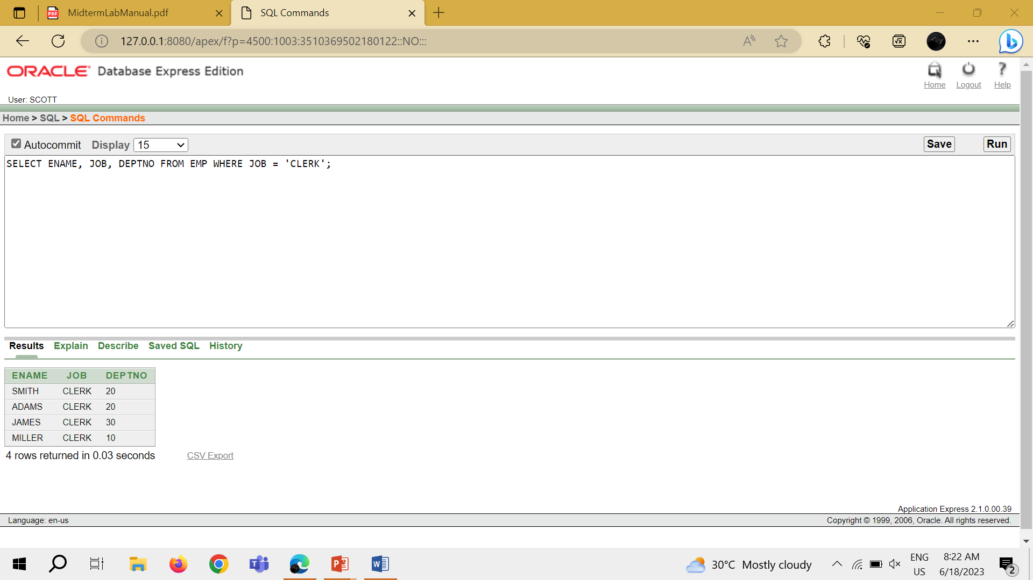

TASK 2: SELECT ENAME, SAL, COMM FROM EMP WHERE SAL<=COMM;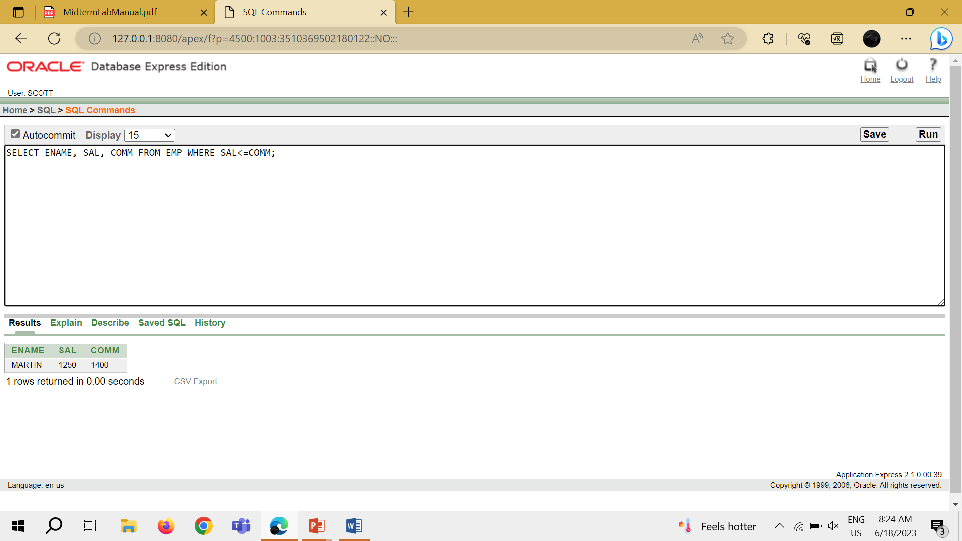

TASK 3: SELECT ENAME, SAL FROM EMP WHERE SAL BETWEEN 1000 AND 1500;

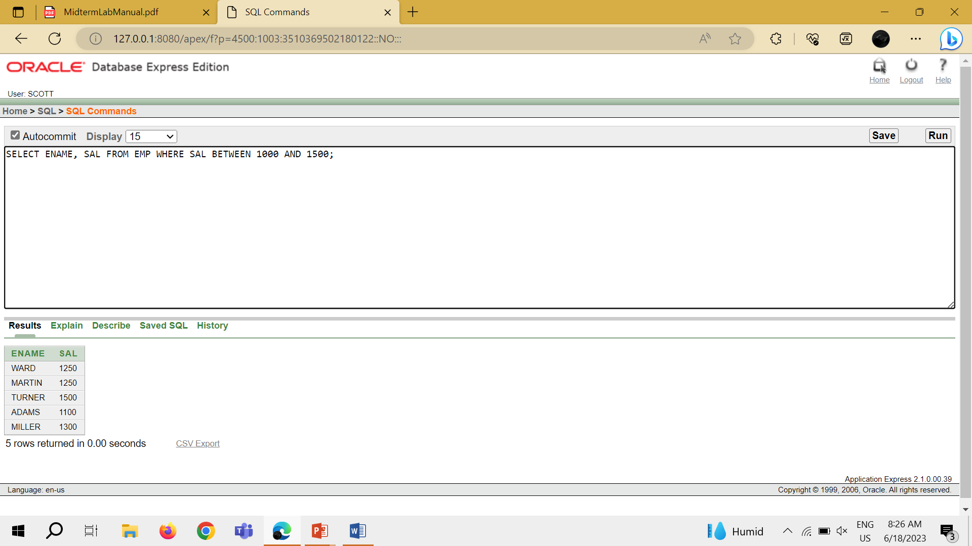

TASK 4: SELECT EMPNO, ENAME, SAL, MGR FROM EMP WHERE MGR IN (7902,7566, 7788);

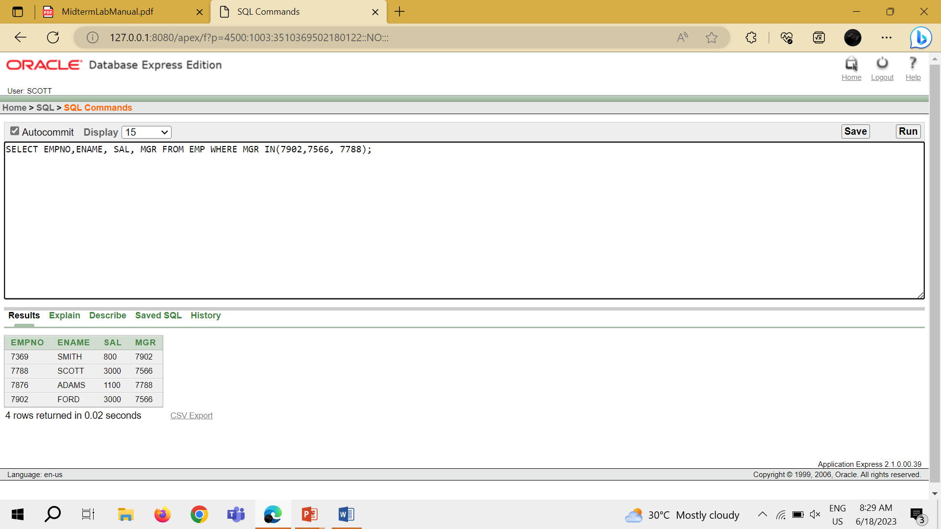

TASK 5: SELECT ENAME FROM EMP WHERE ENAME LIKE '_A%';

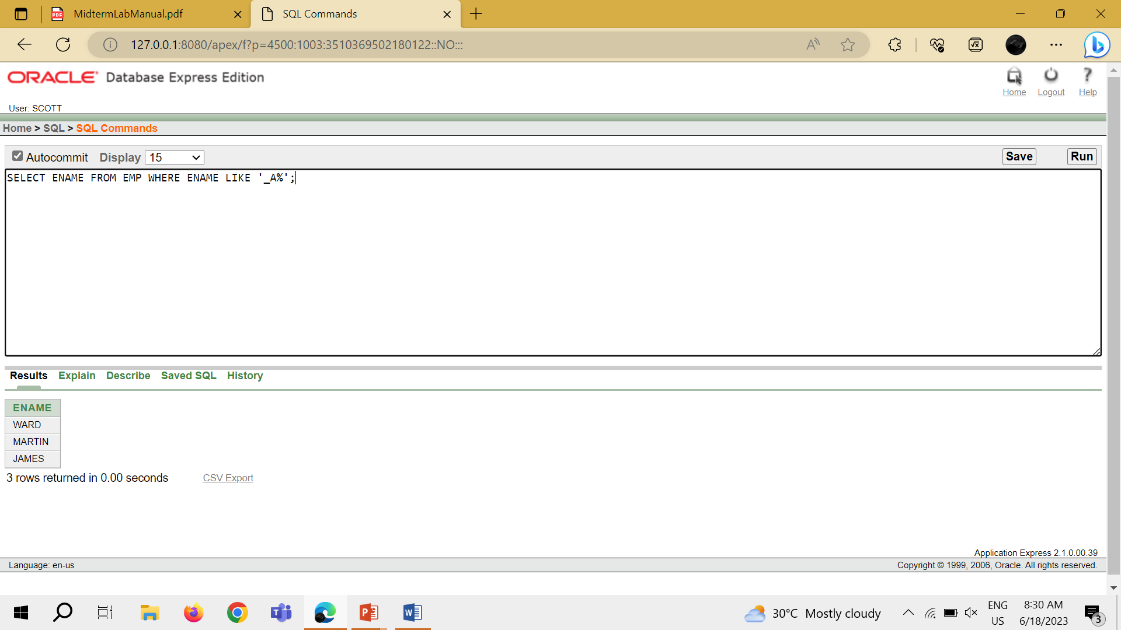

TASK 6: SELECT ENAME, MGR FROM EMP WHERE MGR IS NULL;

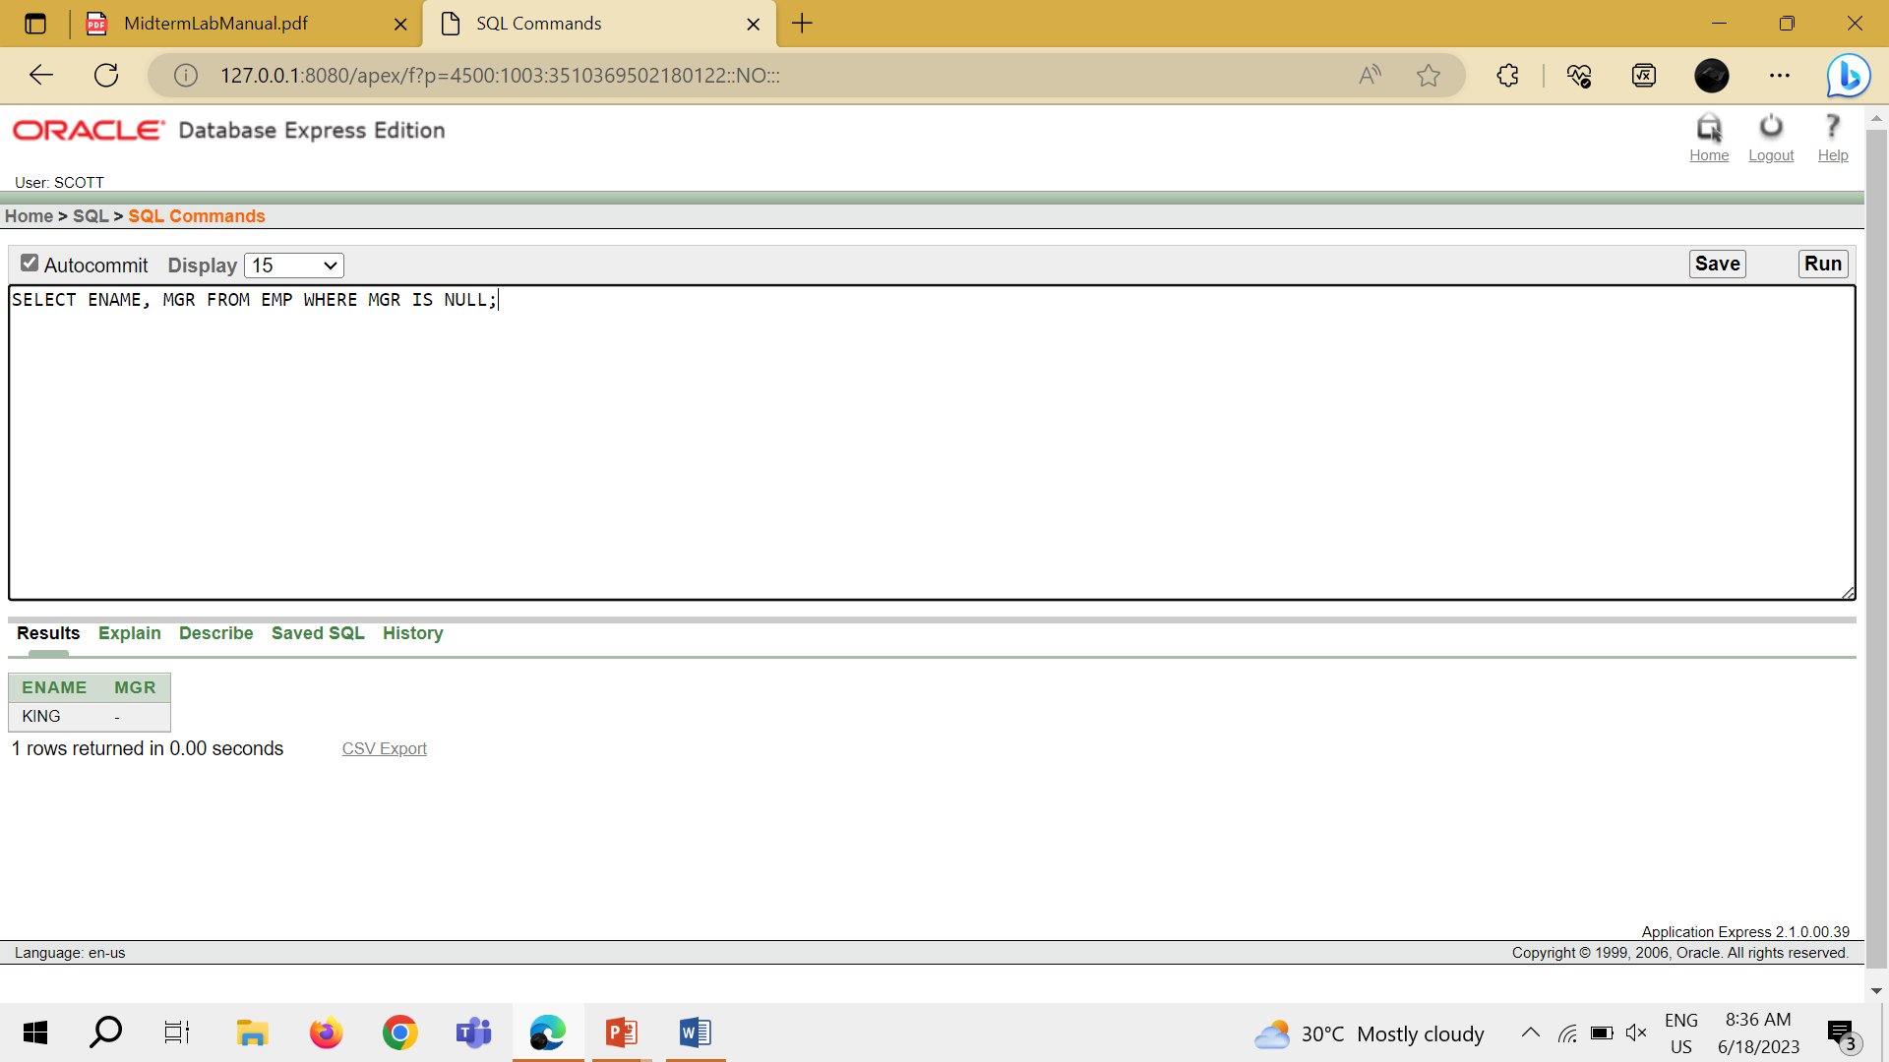

TASK 7: SELECT EMPNO, ENAME, JOB, SAL FROM EMP WHERE SAL >=1100 AND JOB = 'CLERK';

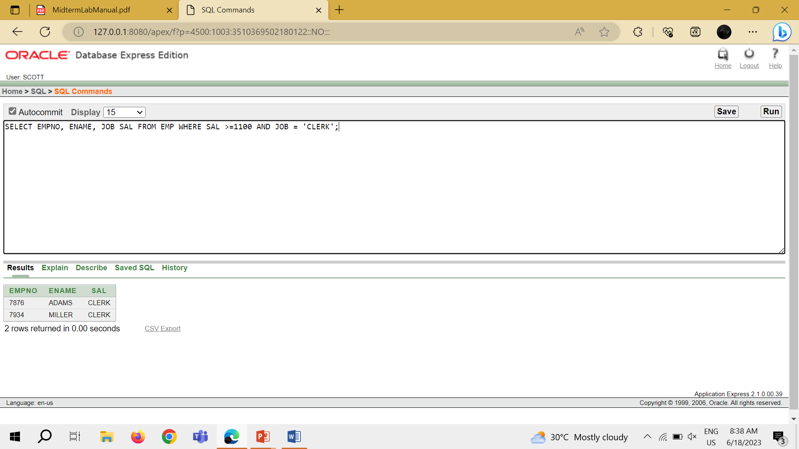

TASK 8: SELECT EMPNO, ENAME, JOB, SAL FROM EMP WHERE SAL >=1100 OR JOB = 'CLERK';

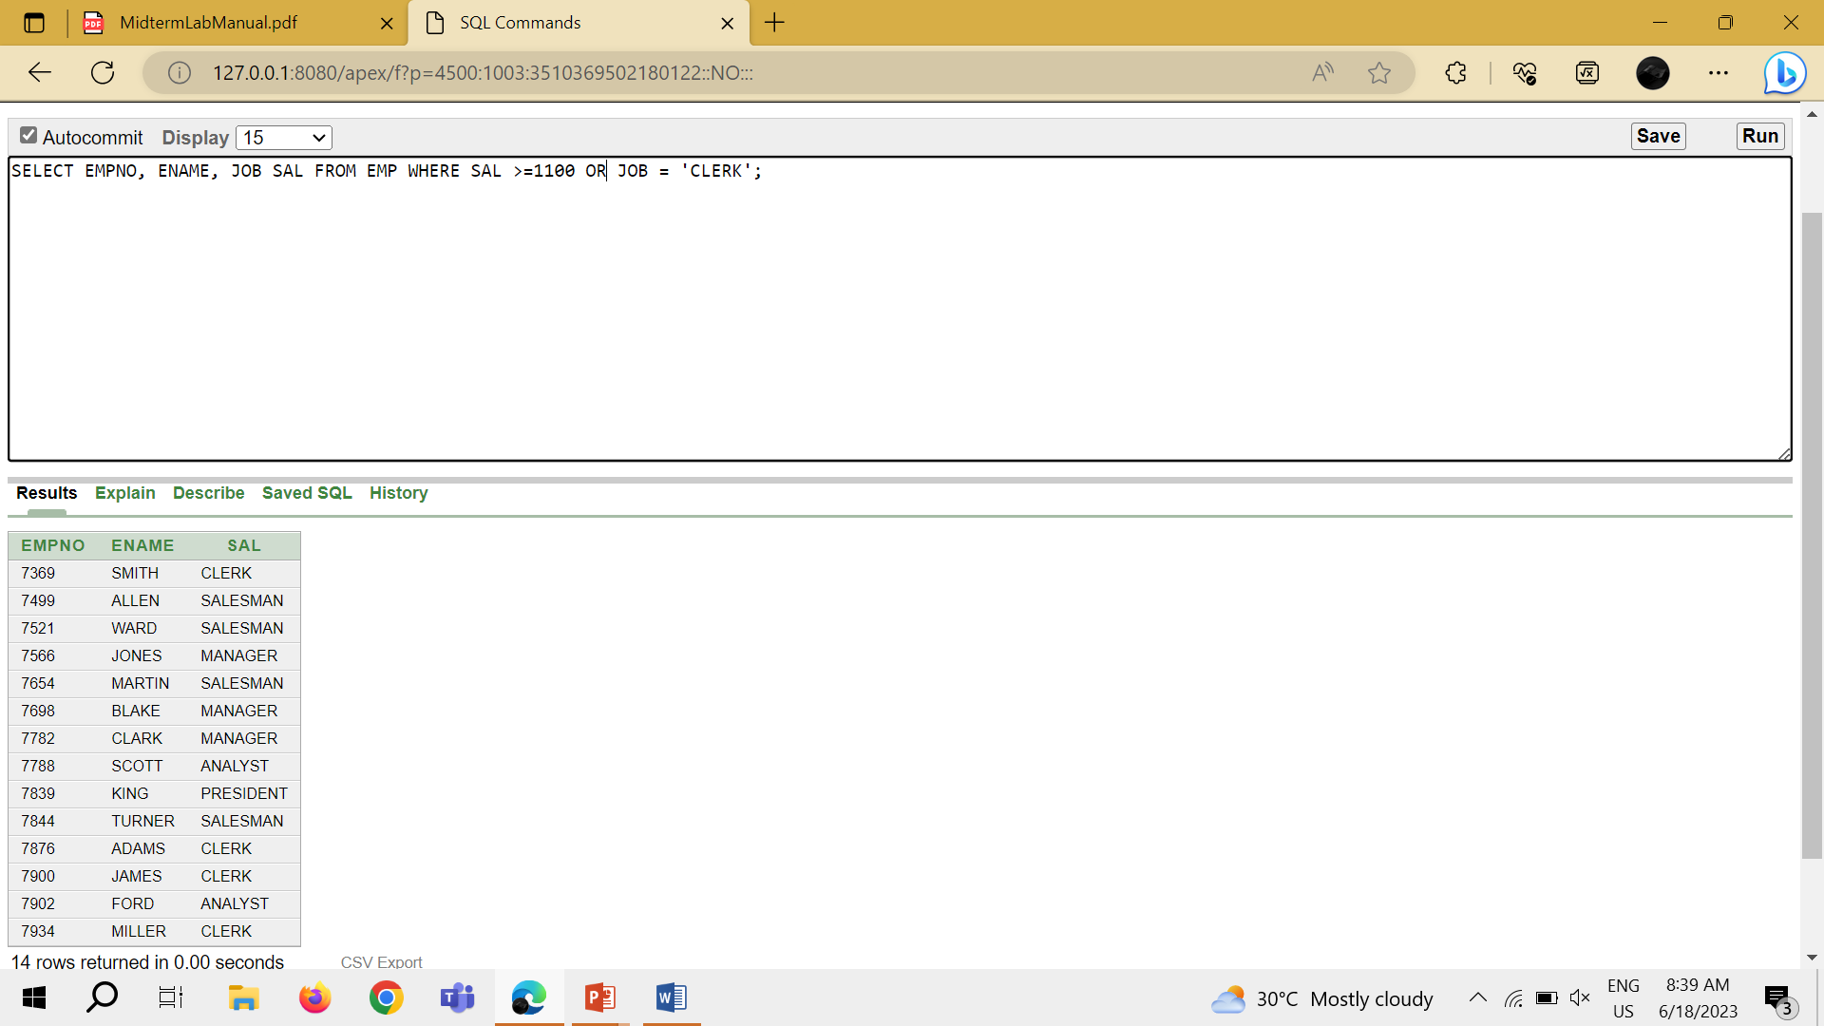

TASK 9: SELECT EMPNO, JOB FROM EMP WHERE JOB NOT IN ('CLERK', 'MANAGER', 'ANALYST');

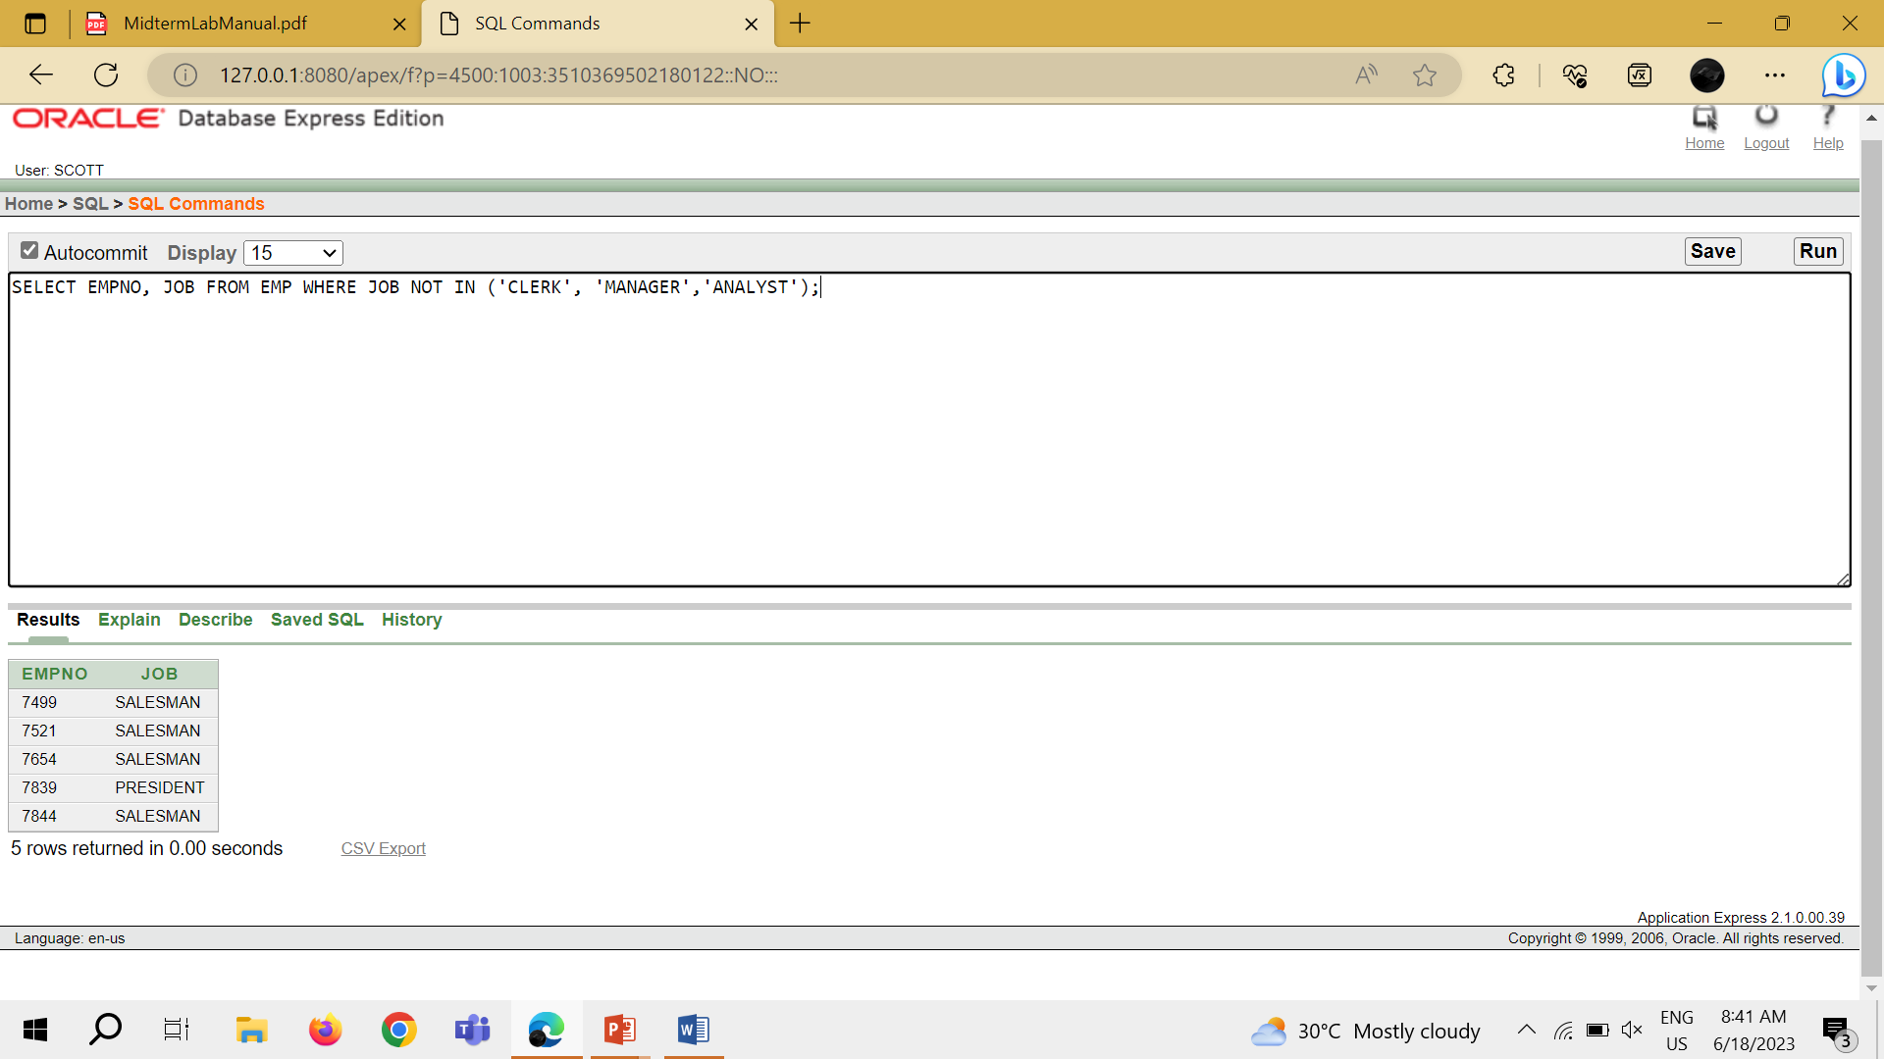

TASK 10: SELECT ENAME, JOB, SAL FROM EMP WHERE (JOB ='SALESMAN' OR JOB = 'PRESIDENT') AND SAL >1500;

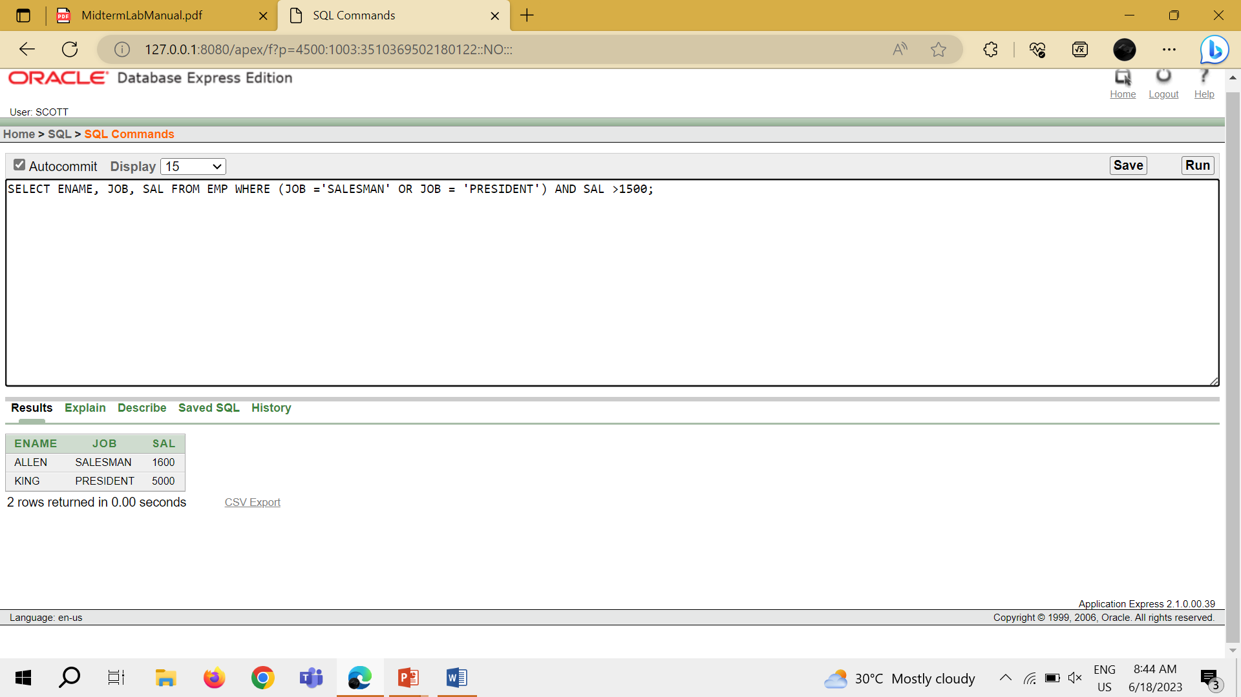

TASK 11: SELECT ENAME, JOB, SAL FROM EMP WHERE JOB ='SALESMAN' OR JOB = 'PRESIDENT' AND SAL >1500;

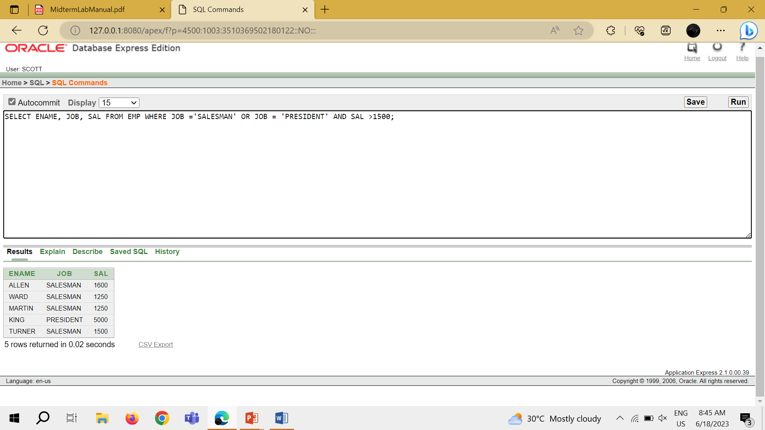

TASK 12: SELECT ENAME , JOB, DEPTNO, HIREDATE FROM EMP ORDER BY HIREDATE;

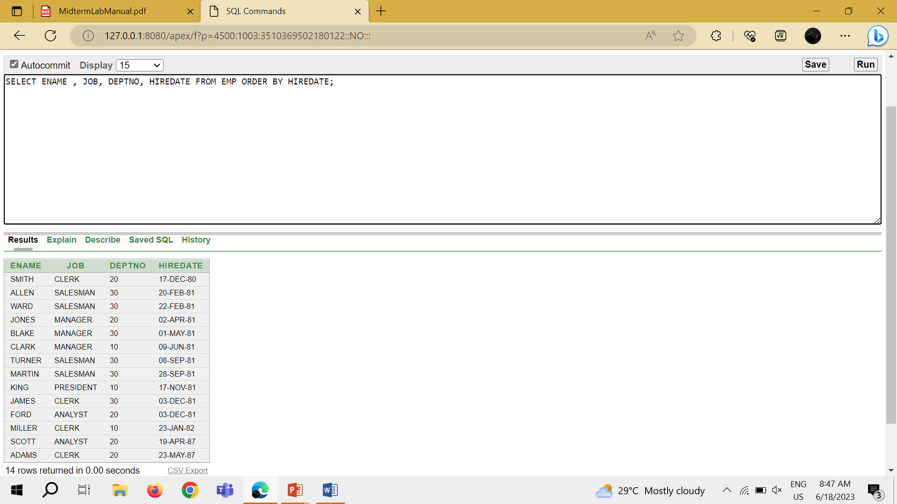

TASK 13: SELECT ENAME , JOB, DEPTNO, HIREDATE FROM EMP ORDER BY HIREDATE DESC;

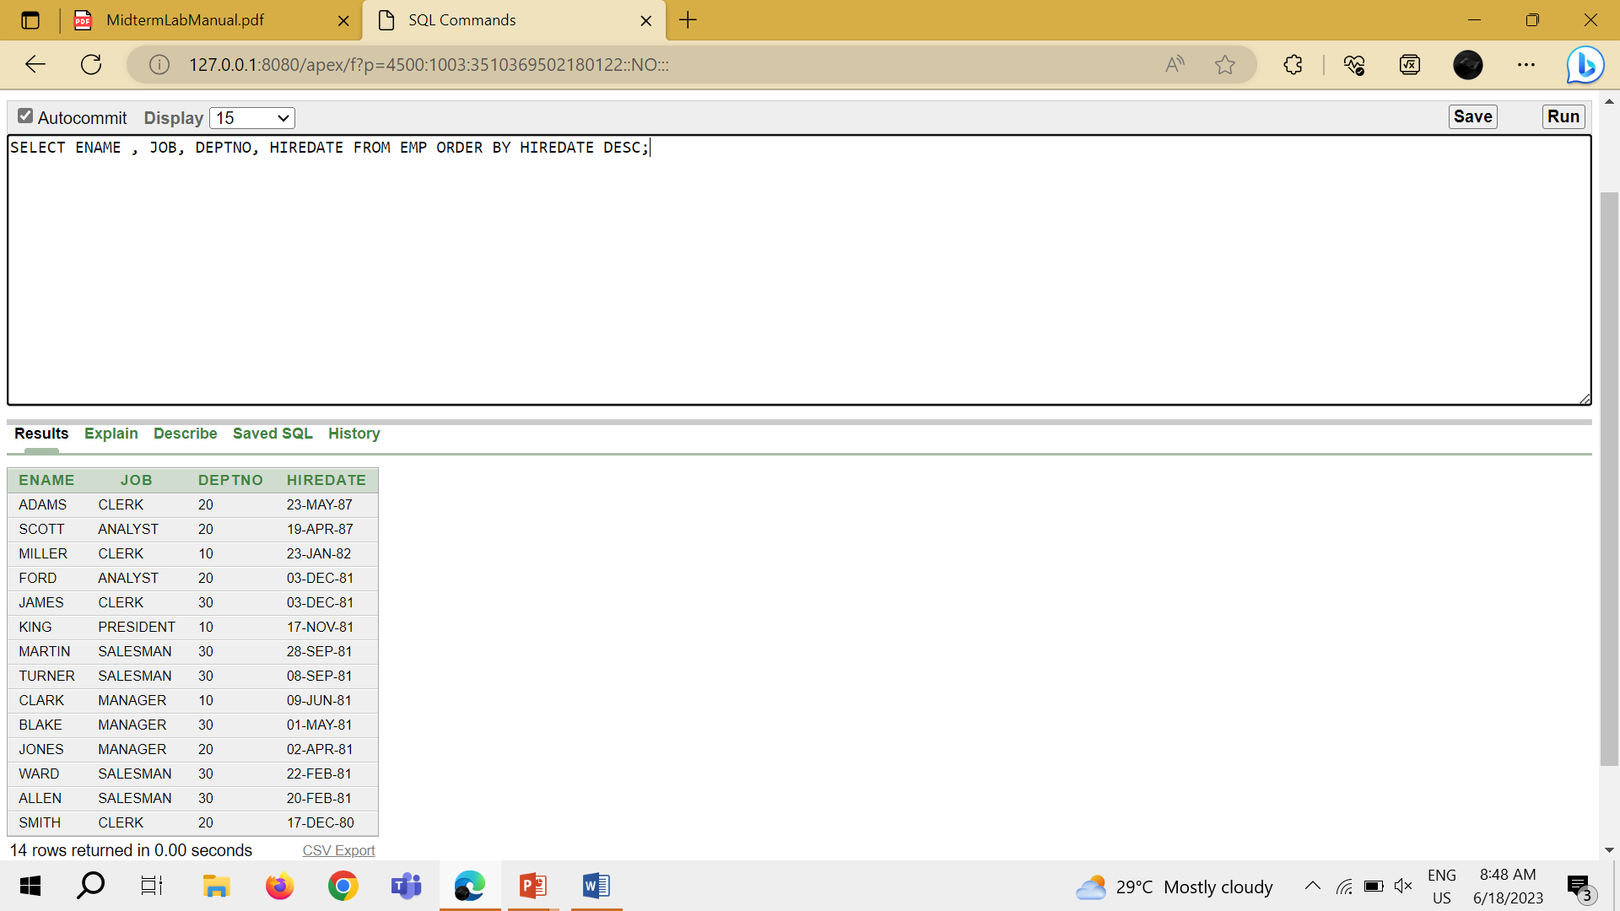

TASK 14: SELECT EMPNO, ENAME , SAL * 12 ANNSAL FROM EMP ORDER BY ANNSAL;

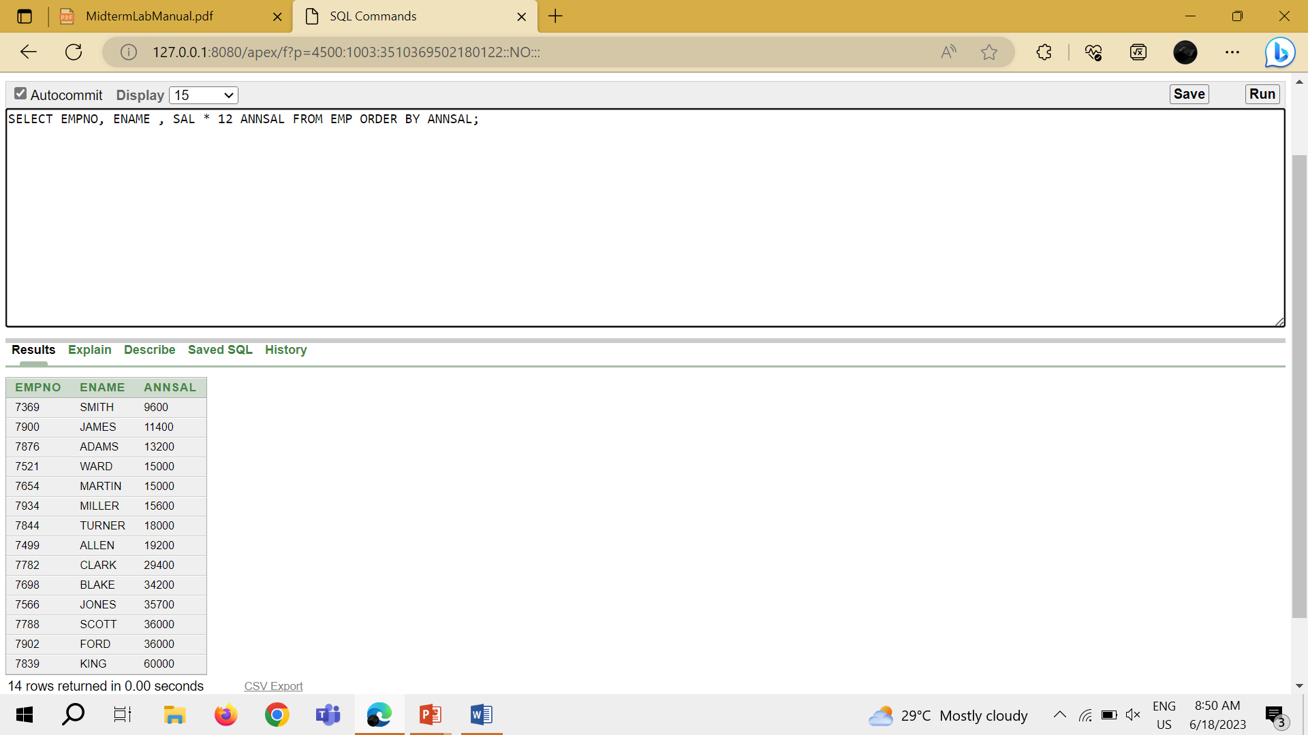

TASK 15: SELECT ENAME, DEPTNO,SAL FROM EMP ORDER BY DEPTNO, SAL DESC;

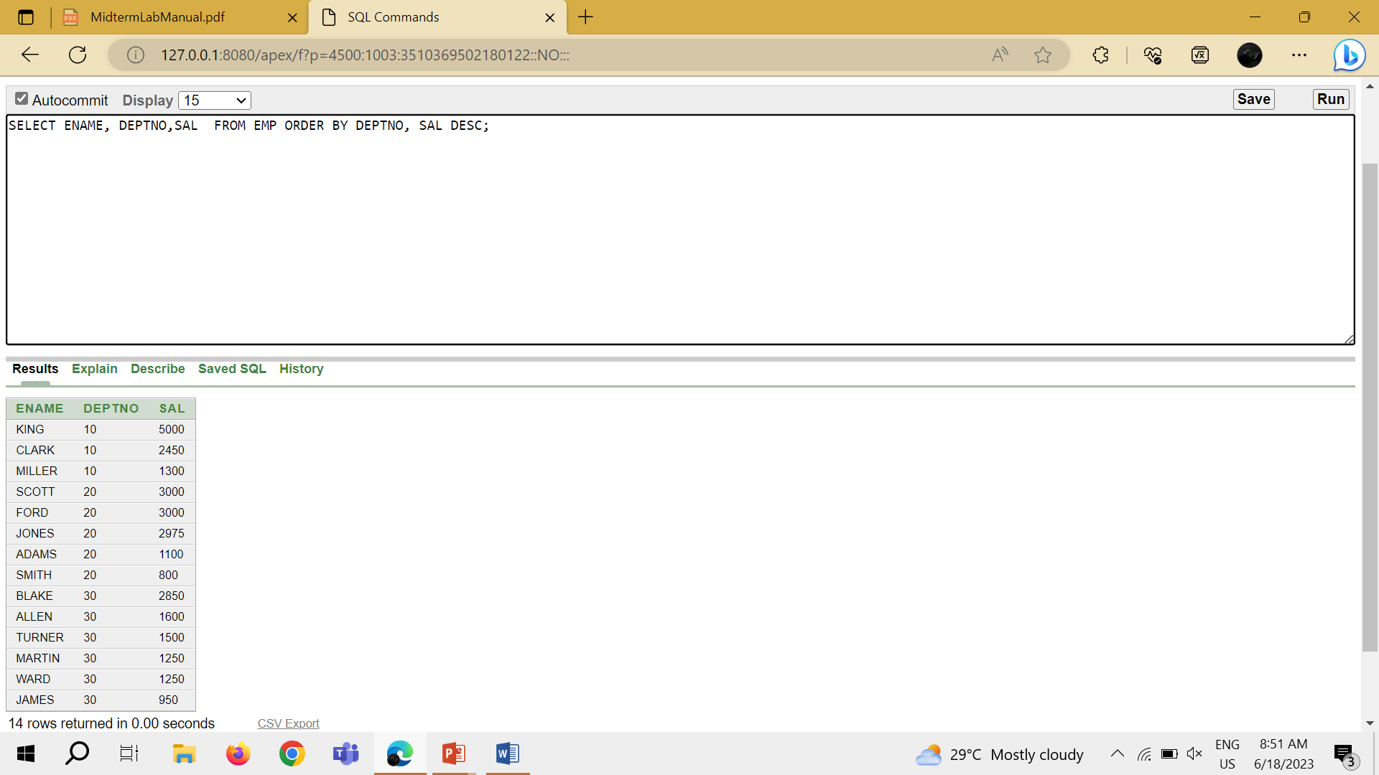

SLIDE 06

TASK 1: SELECT EMPNO, ENAME, DEPTNO FROM EMP WHERE ENAME = 'blake';

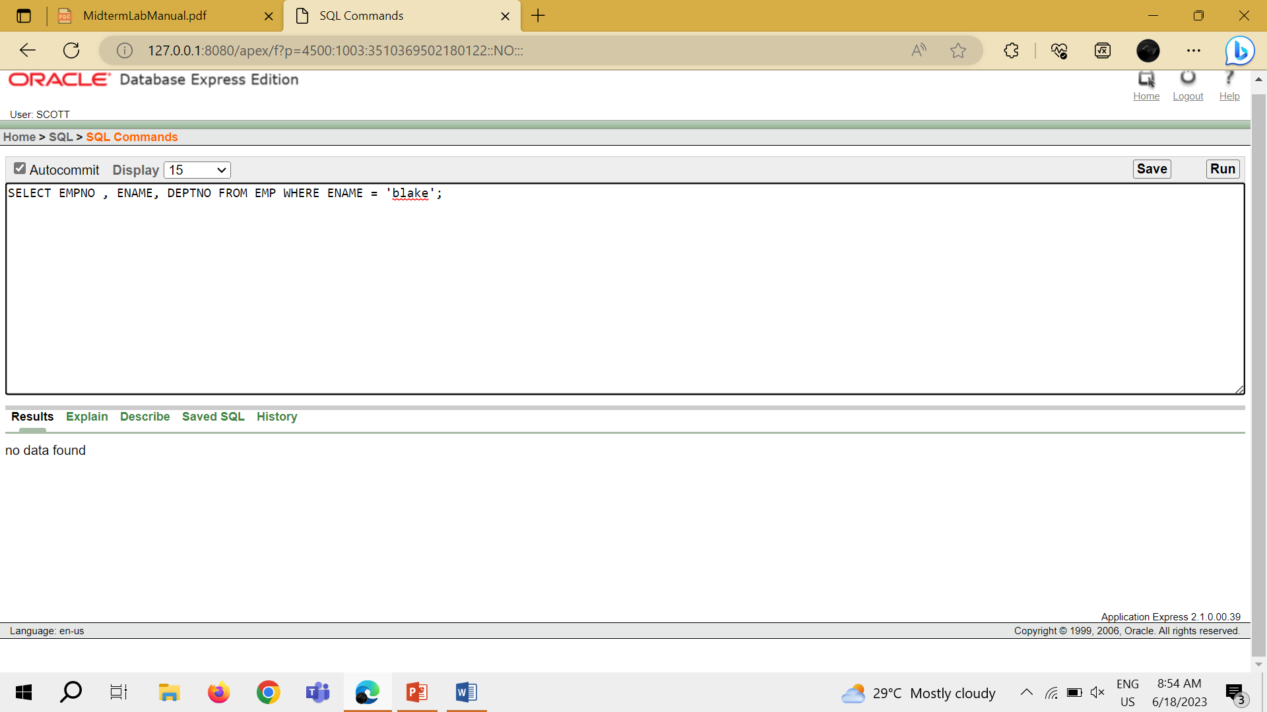

Task 2: SELECT EMPNO , ENAME, DEPTNO FROM EMP WHERE LOWER(ENAME) = 'blake';

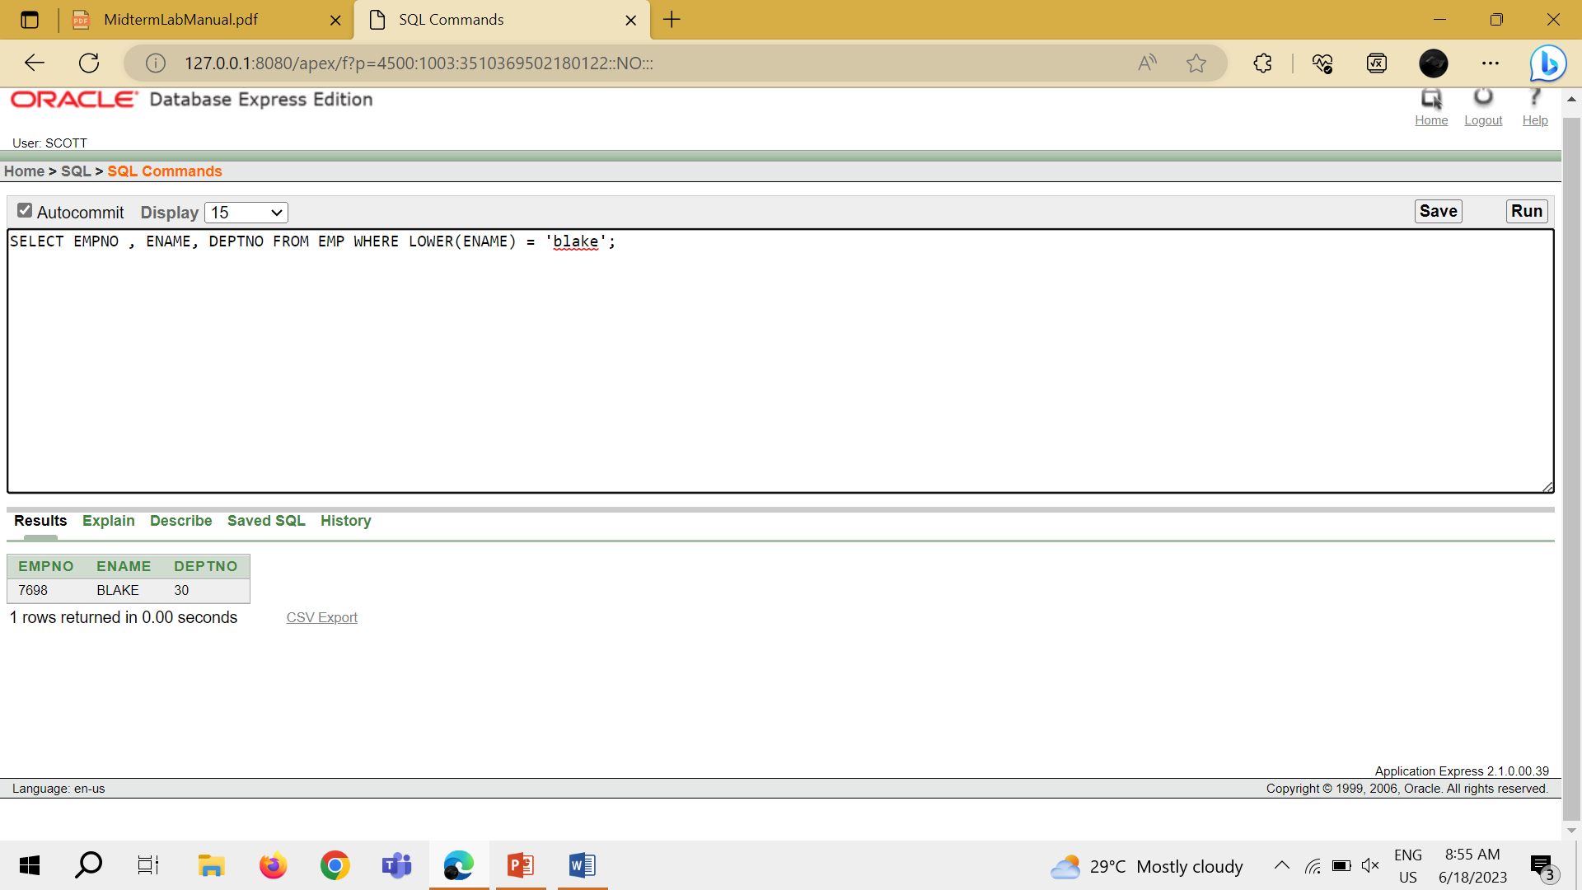

TASK 3: SELECT ENAME, CONCAT (ENAME, JOB), LENGTH (ENAME), INSTR (ENAME, 'A')FROM EMP WHERE SUBSTR (JOB, 1, 5) = 'SALES';

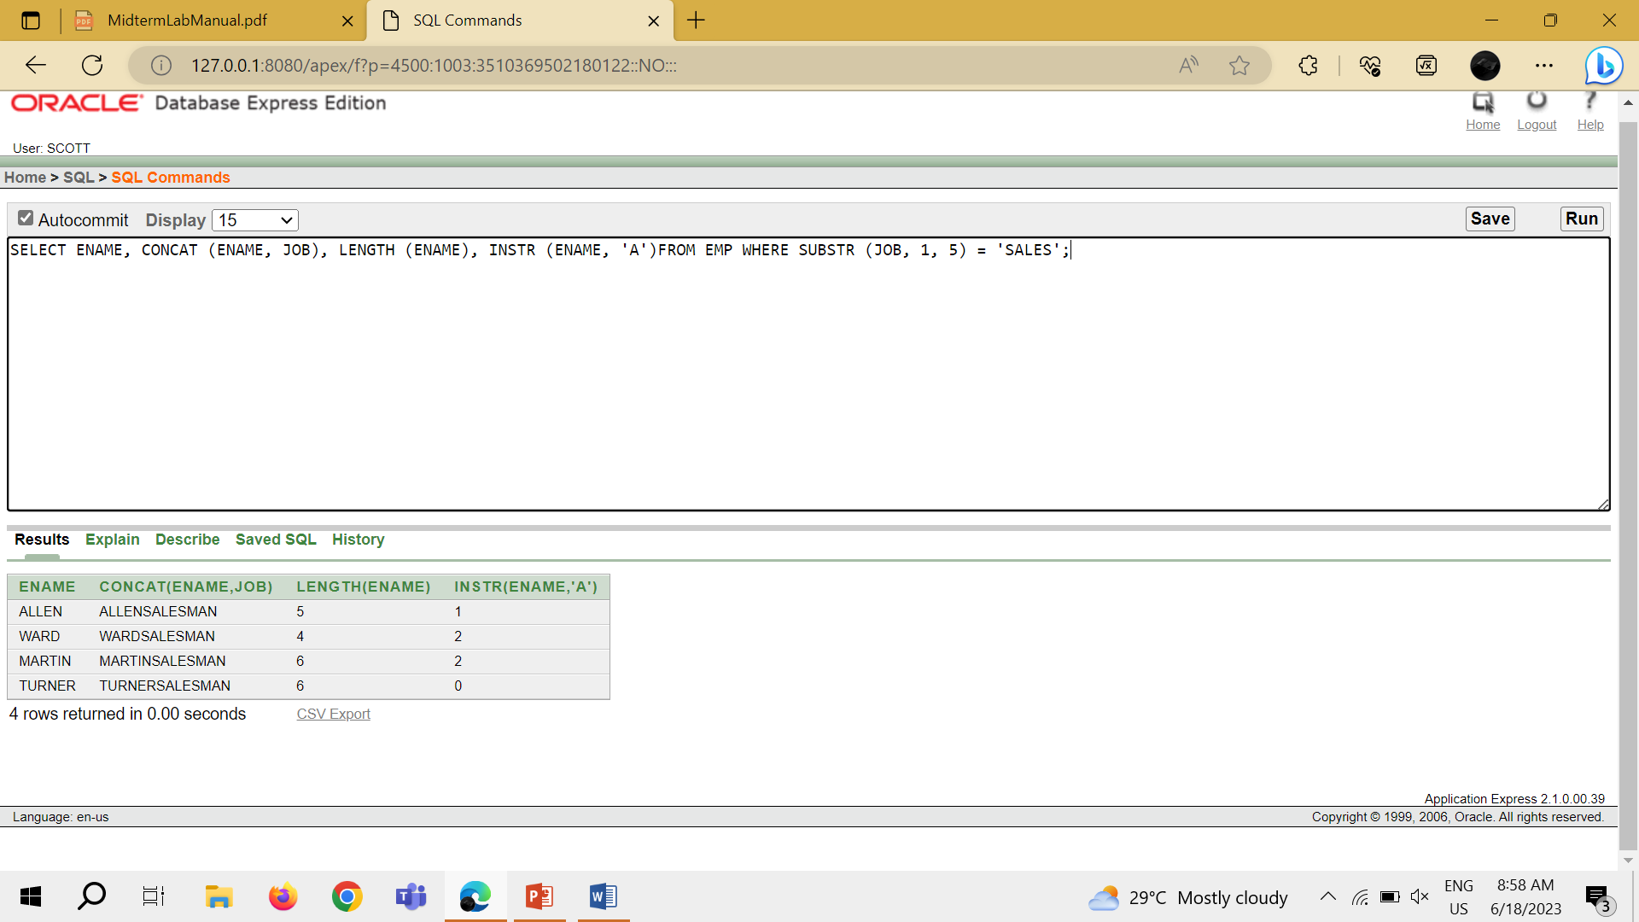

TASK 4: SELECT ROUND (45.923, 2), ROUND (45.923, 0), ROUND (45.923, -1) FROM DUAL;

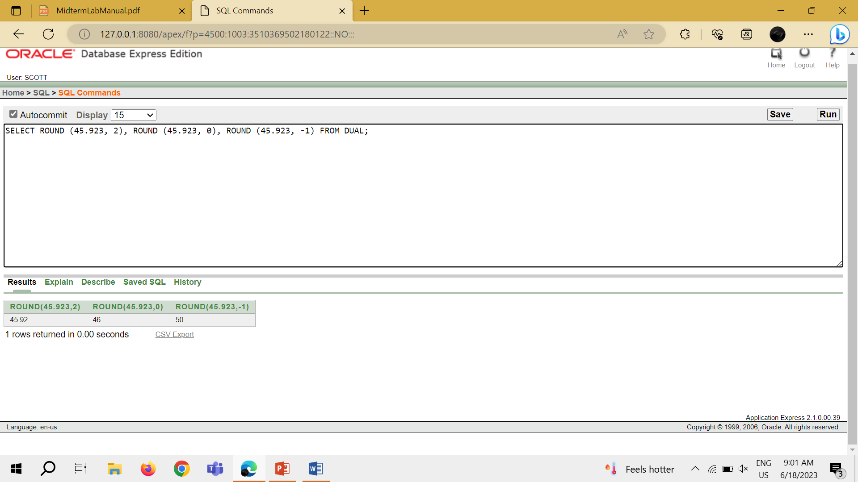

TASK 5: SELECT TRUNC (45.923, 2), TRUNC (45.923), TRUNC (45.923, -1) FROM DUAL;

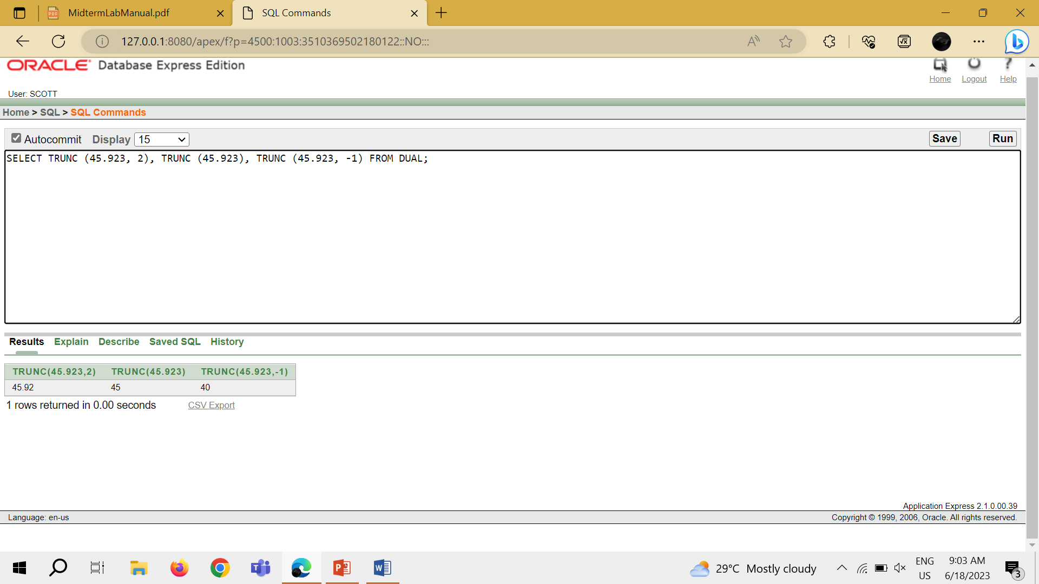

TASK 6: SELECT ENAME, SAL, COMM, MOD (SAL, COMM) FROM EMP WHERE JOB = 'SALESMAN';

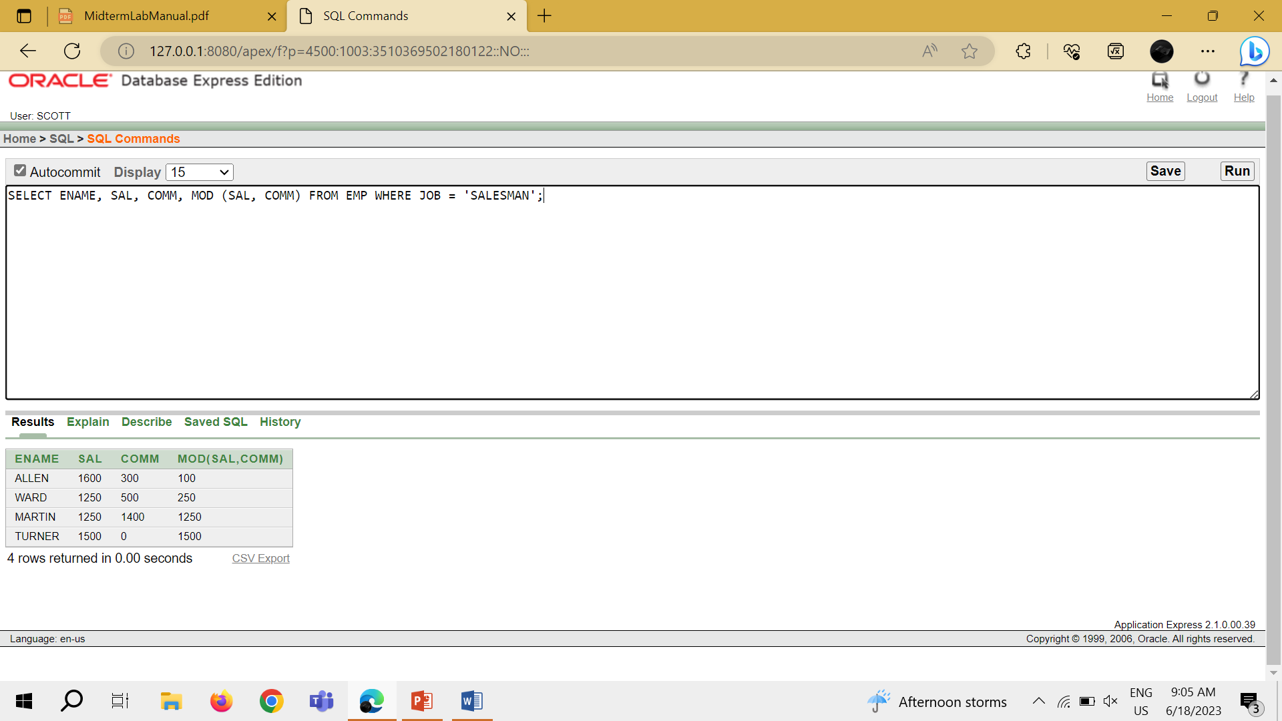

TASK 7: SELECT ENAME, (SYSDATE - HIREDATE)/7 WEEKS FROM EMP WHERE DEPTNO = 10;

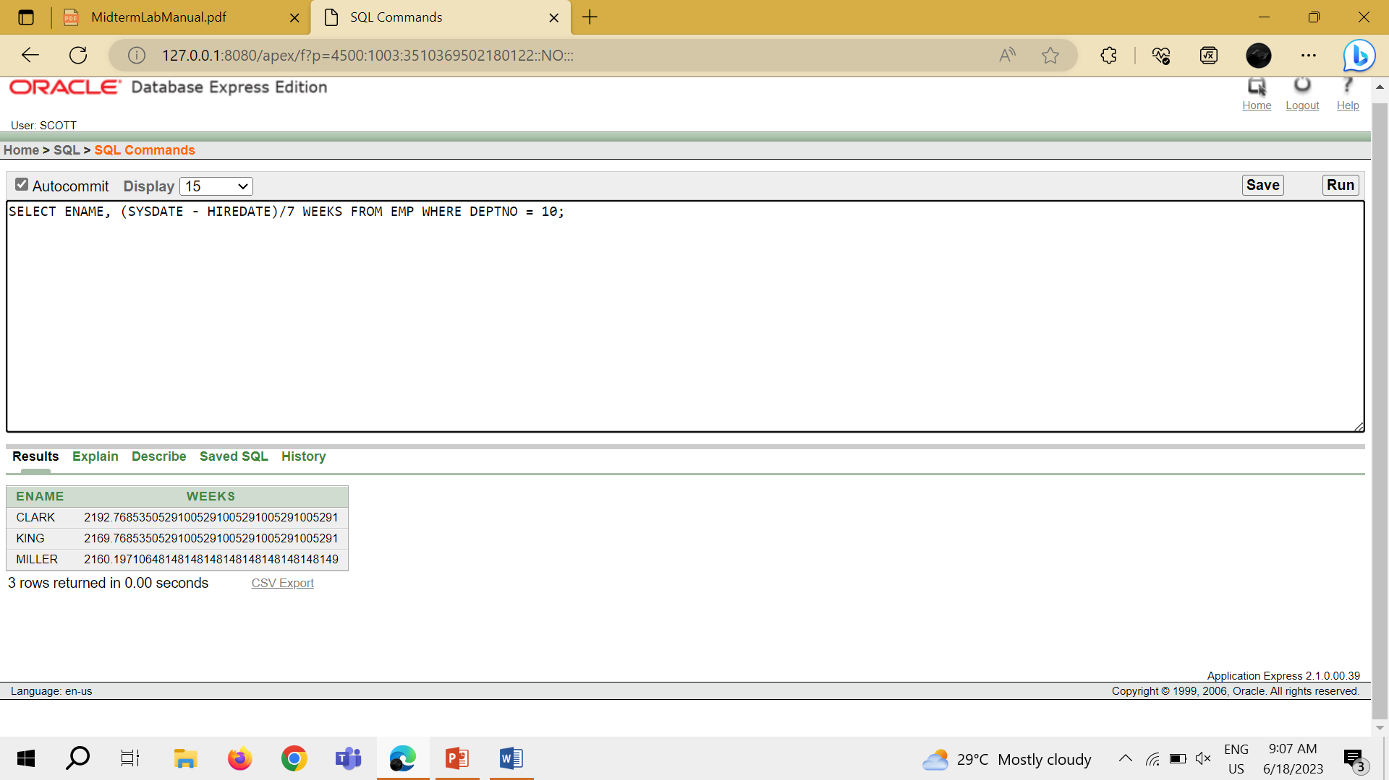

TASK 8: SELECT ENAME, TO_CHAR(HIREDATE, 'FMDD MONTH YYYY') HIREDATE FROM EMP;

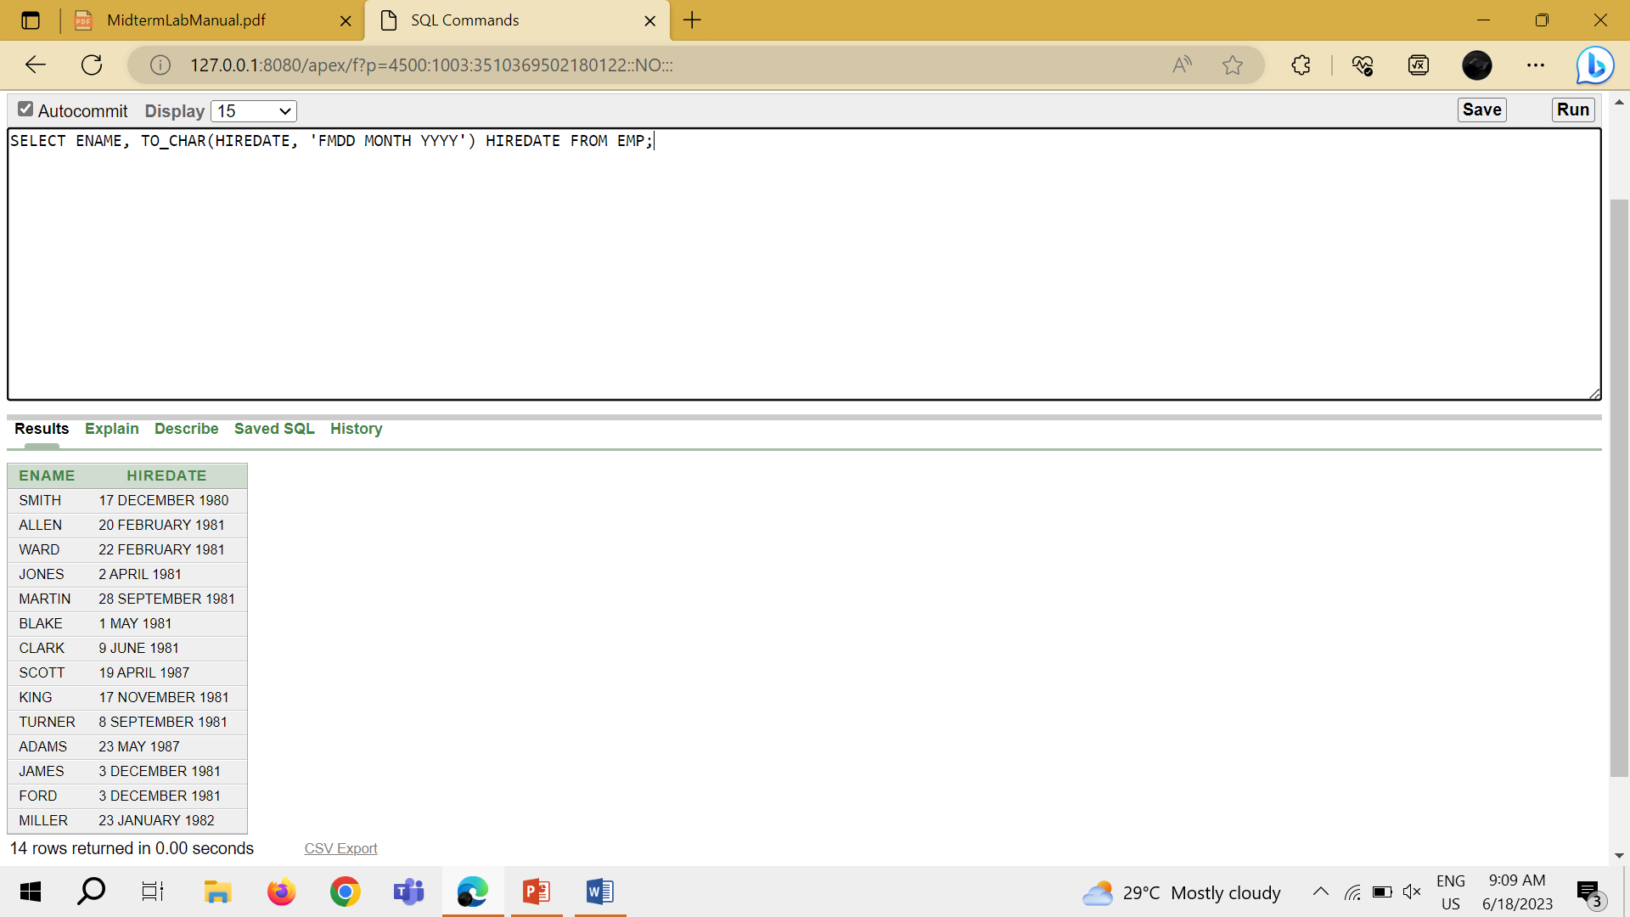

TASK 9: SELECT TO_CHAR(SAL, '$99,999') SALARY FROM EMP WHERE ENAME = 'SCOTT';

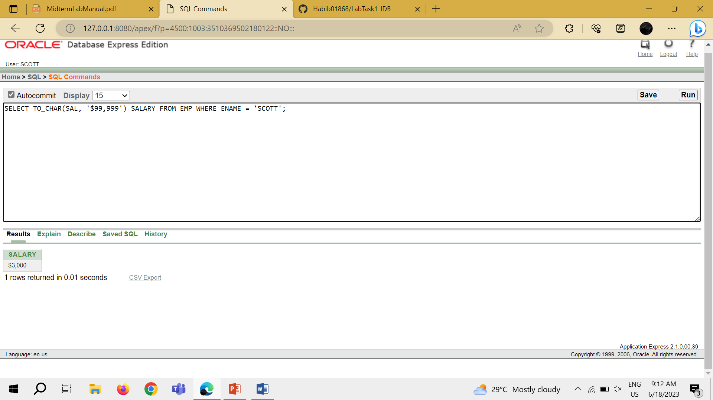

TASK 10: SELECT ENAME, SAL, COMM, (SAL*12)+NVL(COMM, 0) FROM EMP;

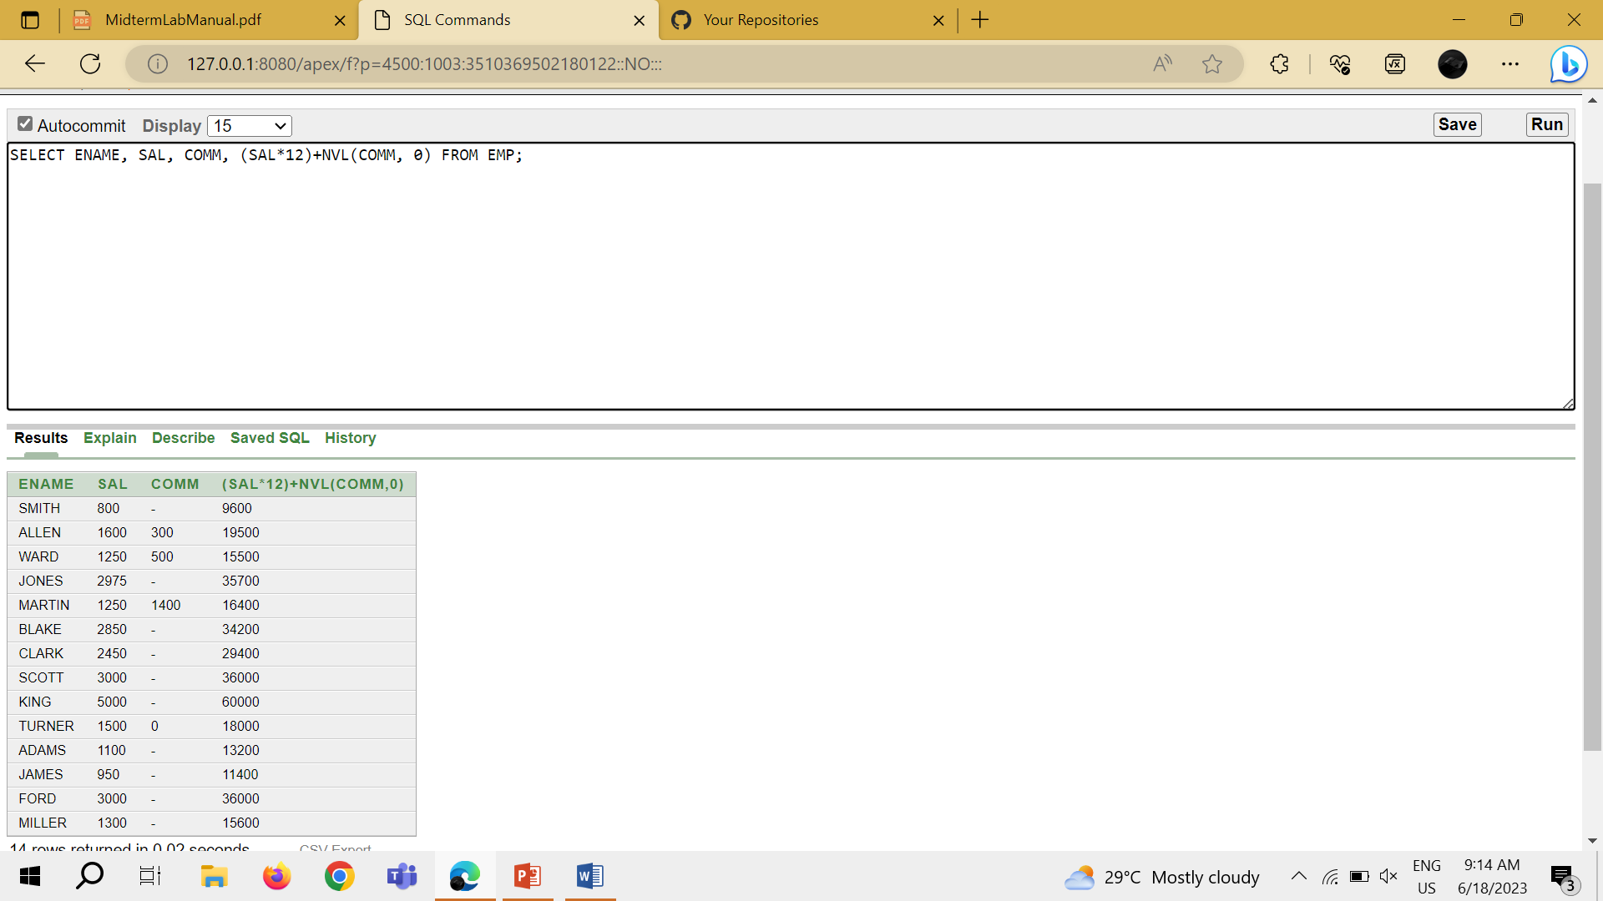

TASK 11: SELECT JOB, SAL, DECODE (JOB, 'ANALYST', SAL*1.1, 'CLERK', SAL*1.15, 'MANAGER', SAL*1.20, SAL) REVISED_SALARY FROM EMP;

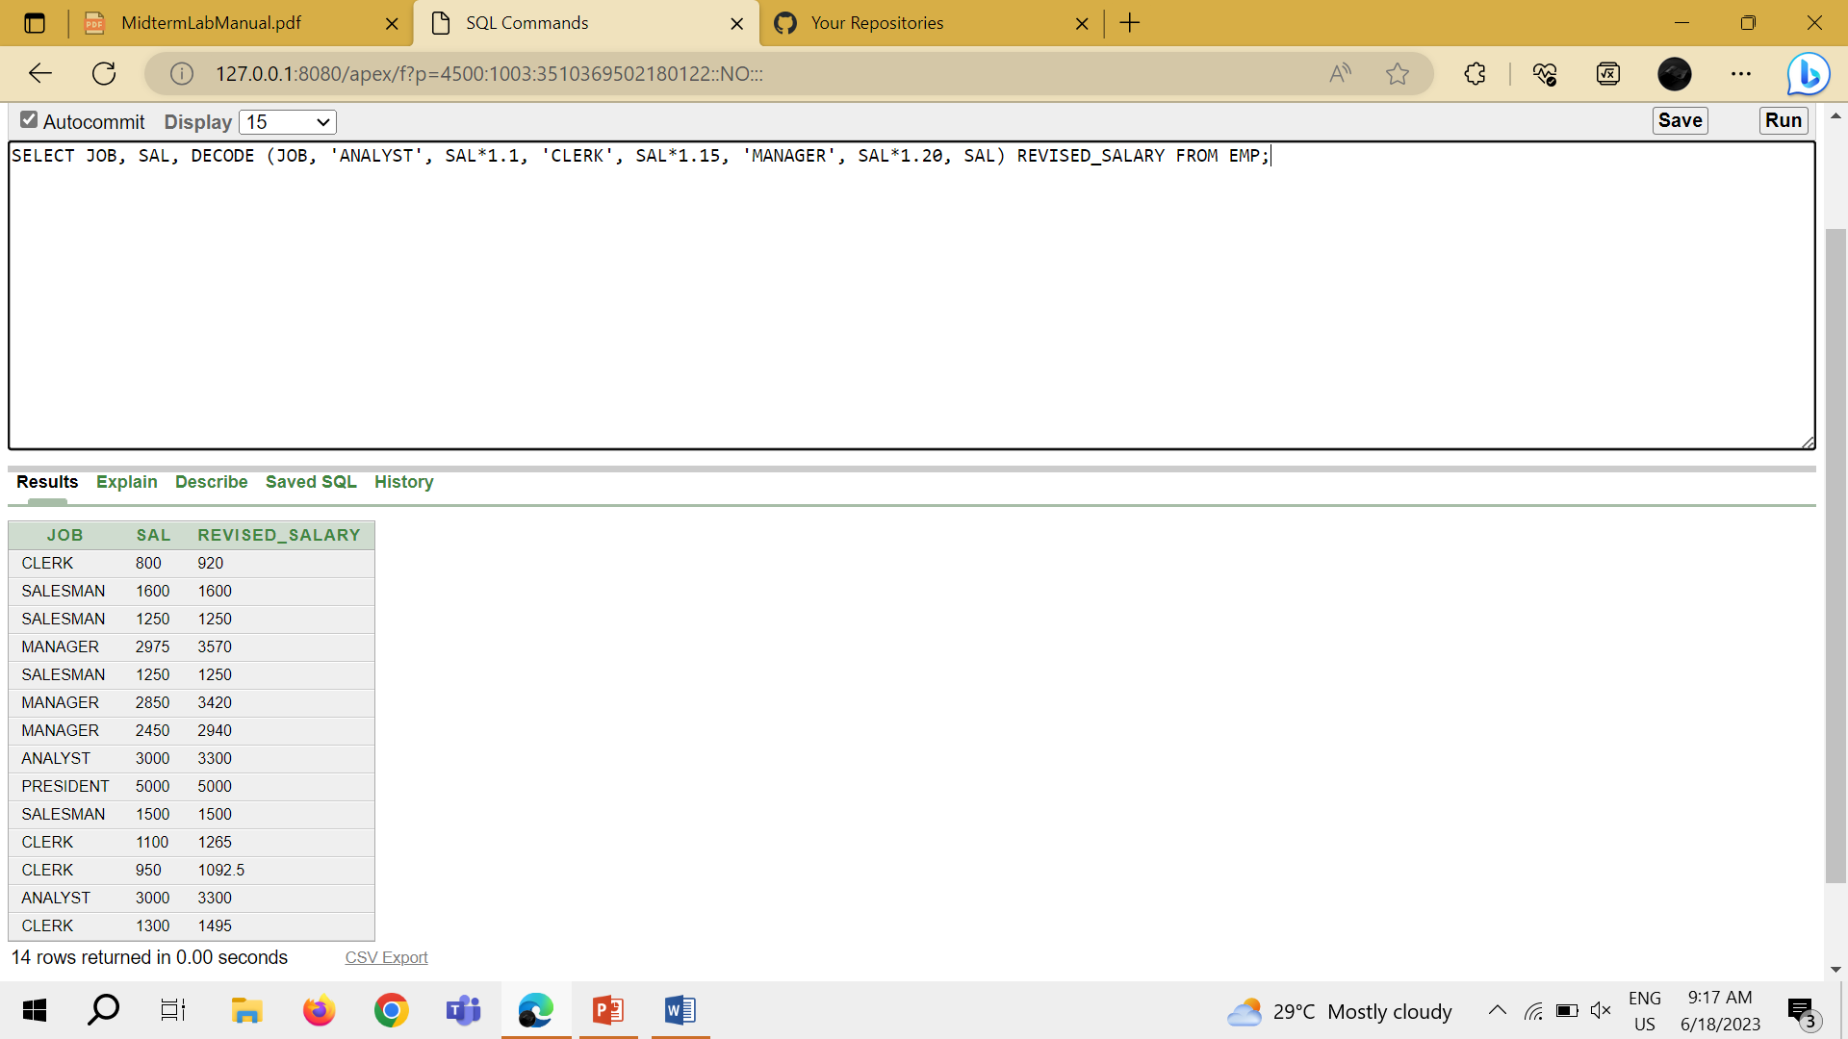

TASK 12: SELECT ENAME, NVL (TO_CHAR(MGR), 'NO MANAGER') FROM EMP WHERE MGR IS NULL;

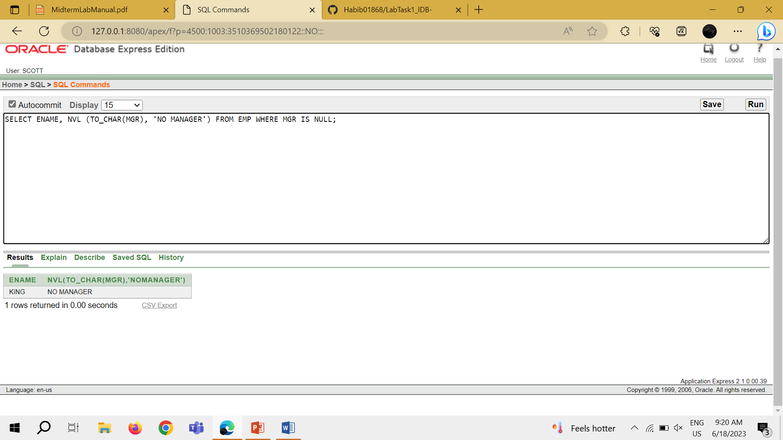

SLIDE 08

TASK 1: SELECT AVG(SAL), MAX(SAL), MIN(SAL), SUM(SAL) FROM EMP WHERE JOB LIKE 'SALES%';

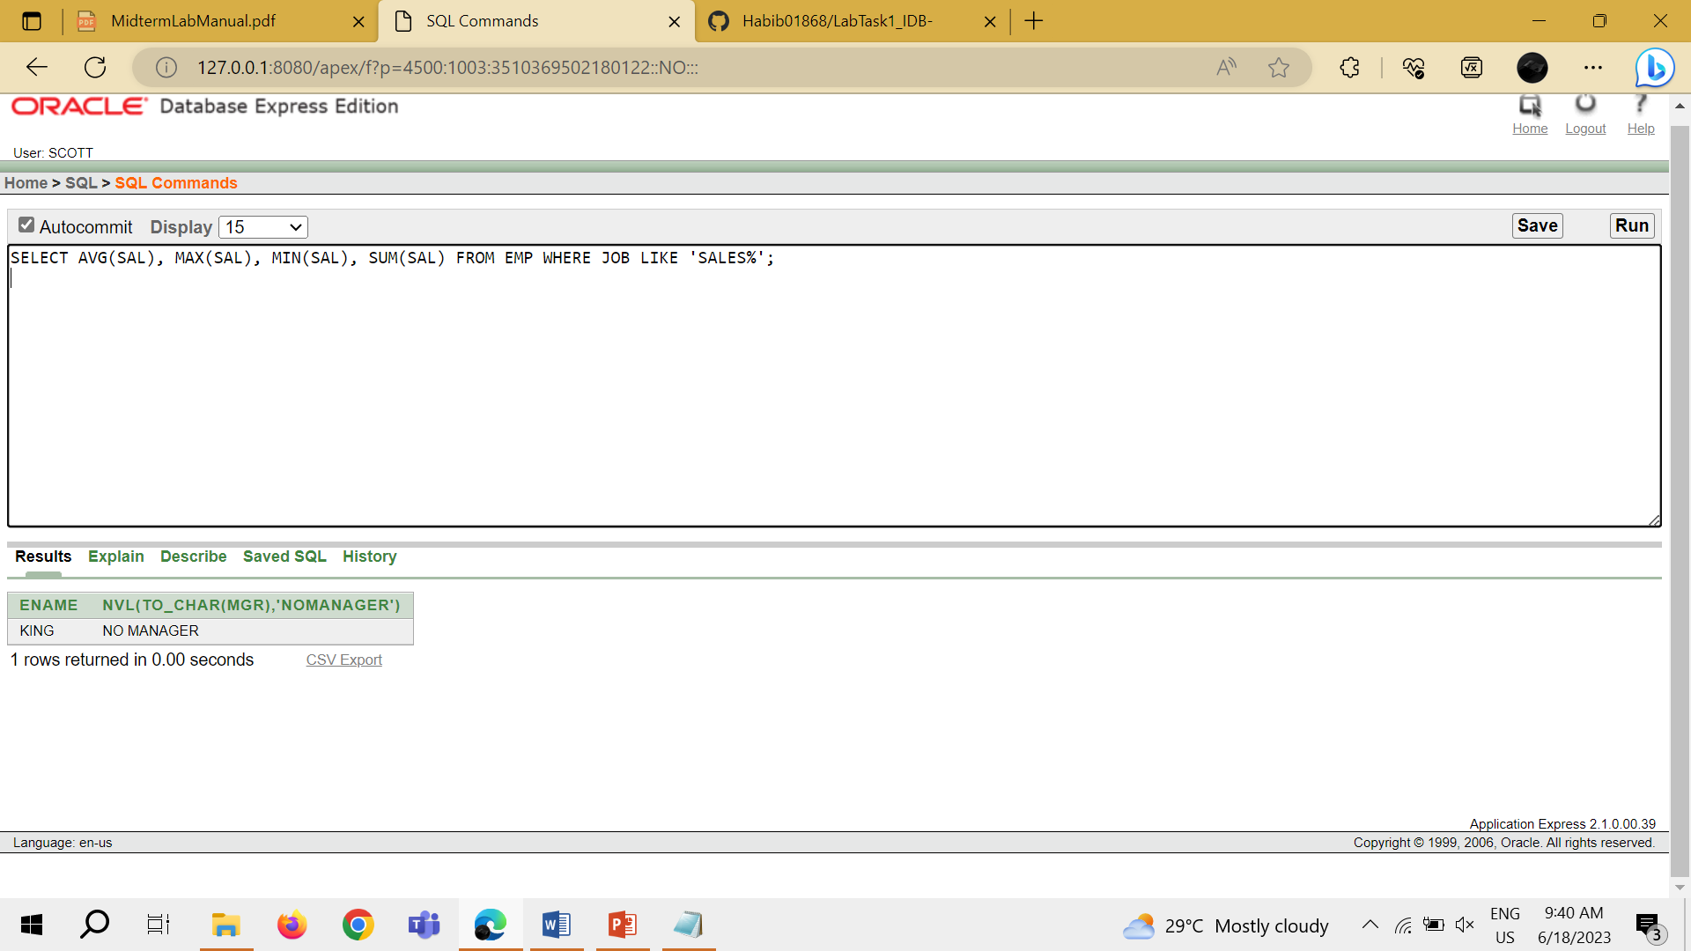

TASK 2: SELECT MIN(HIREDATE), MAX(HIREDATE) FROM EMP;

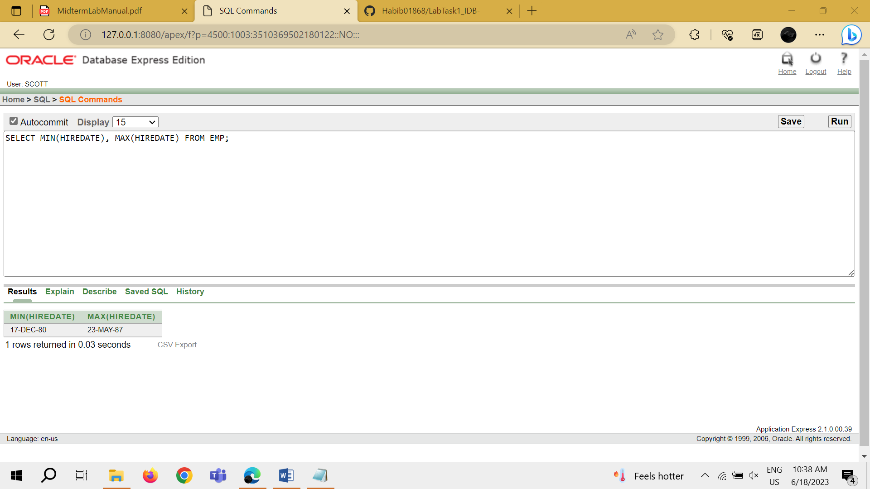

TASK 3: SELECT COUNT(*) FROM EMP WHERE DEPTNO = 30;

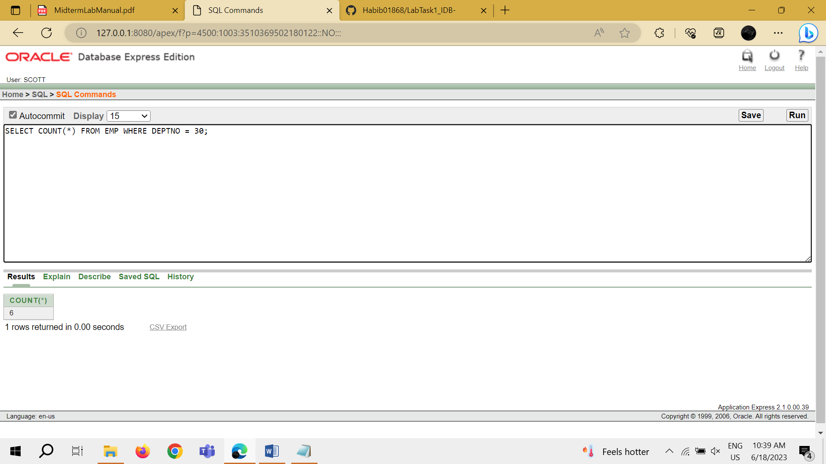

TASK 4: SELECT COUNT (COMM) FROM EMP WHERE DEPTNO = 30;

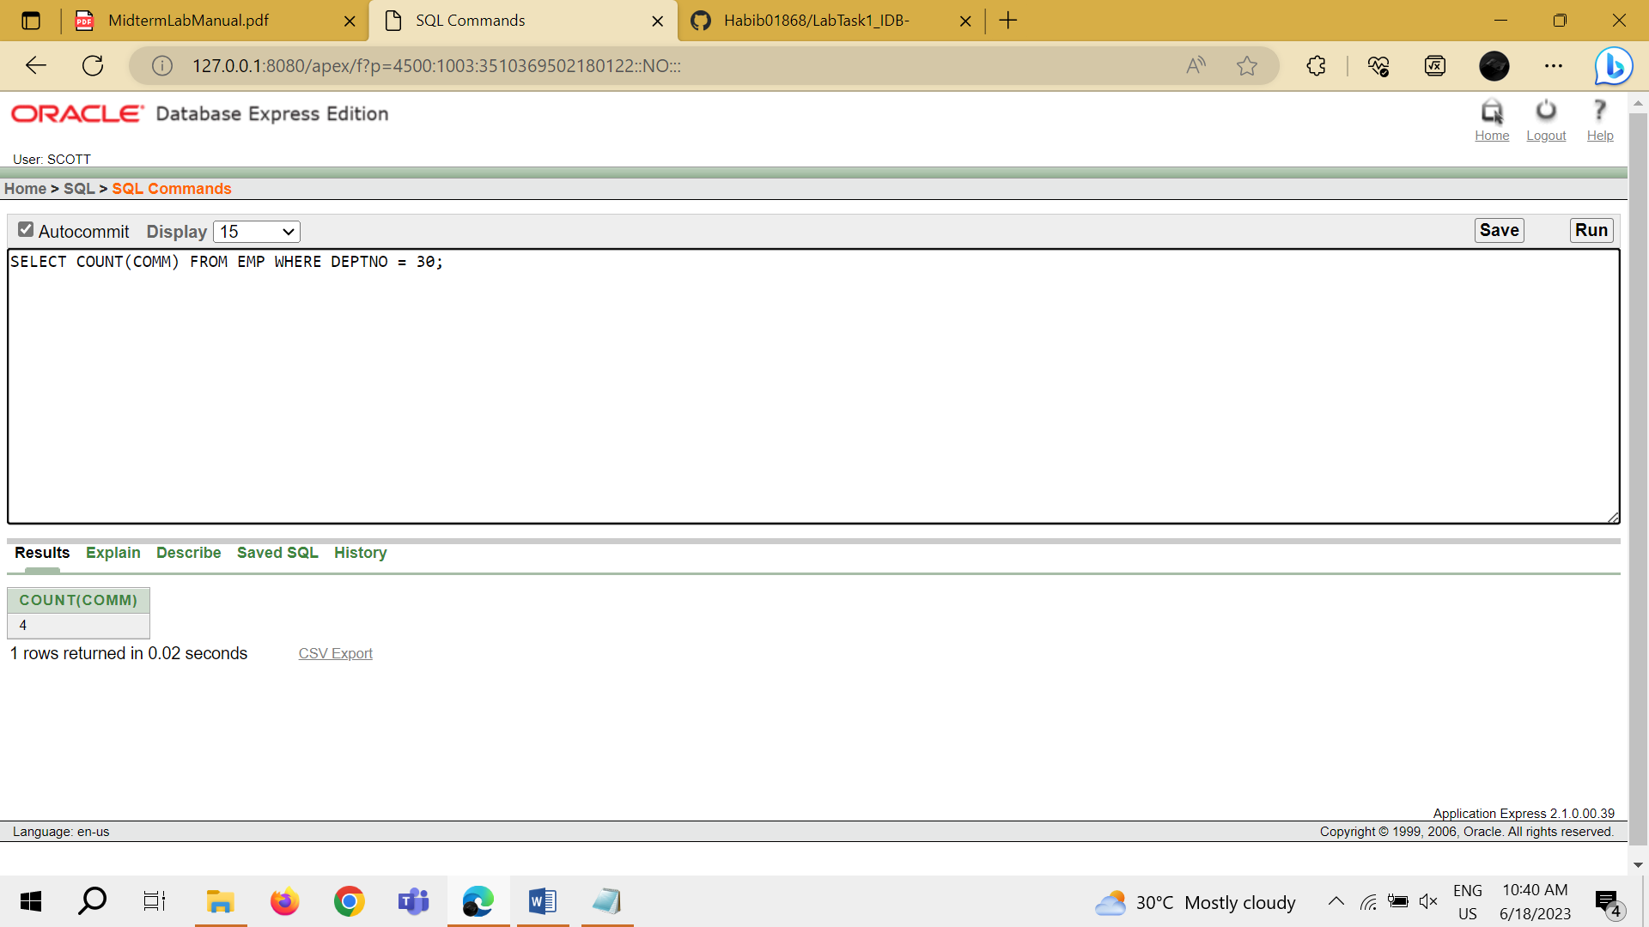

TASK 5: SELECT AVG (COMM) FROM EMP;

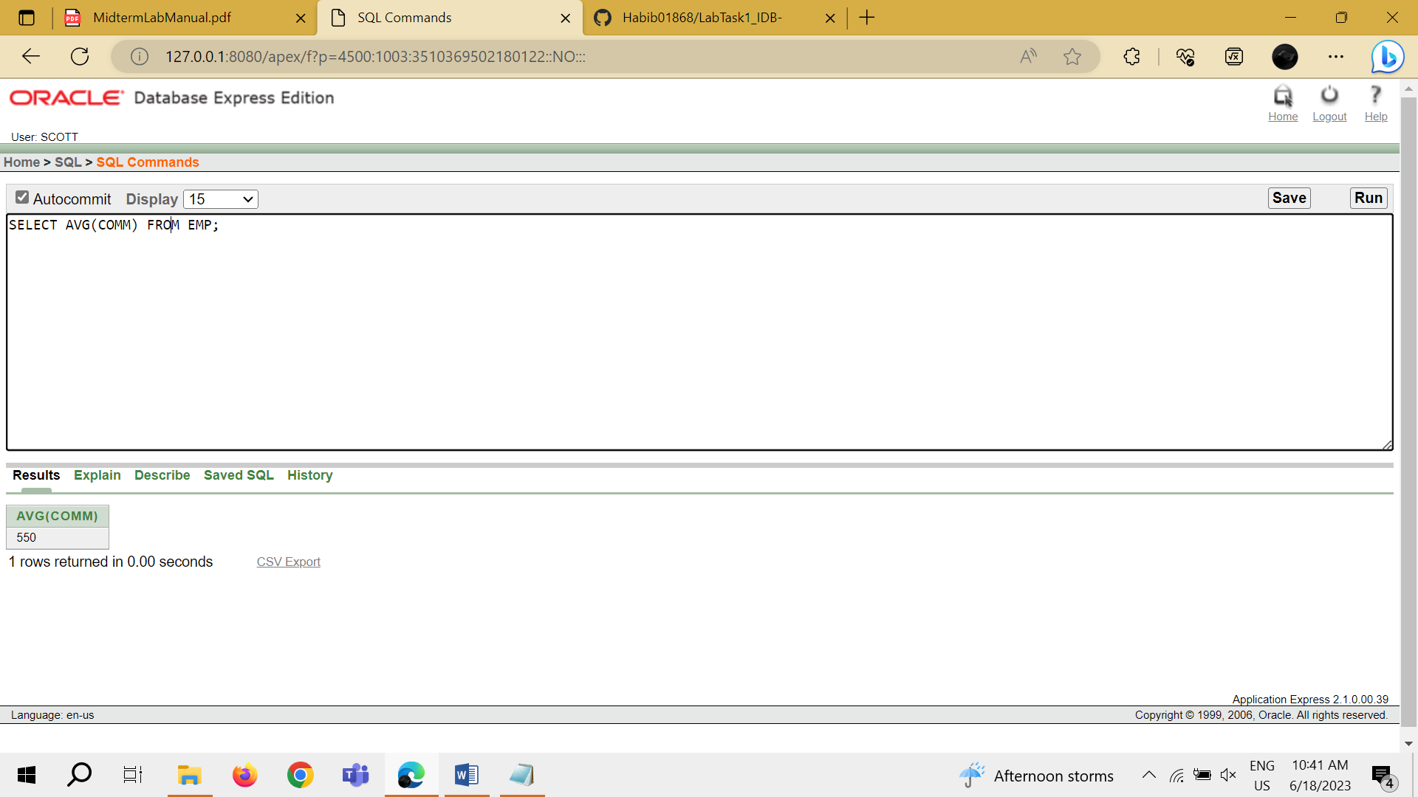

TASK 6: SELECT AVG (NVL (COMM, 0)) FROM EMP;

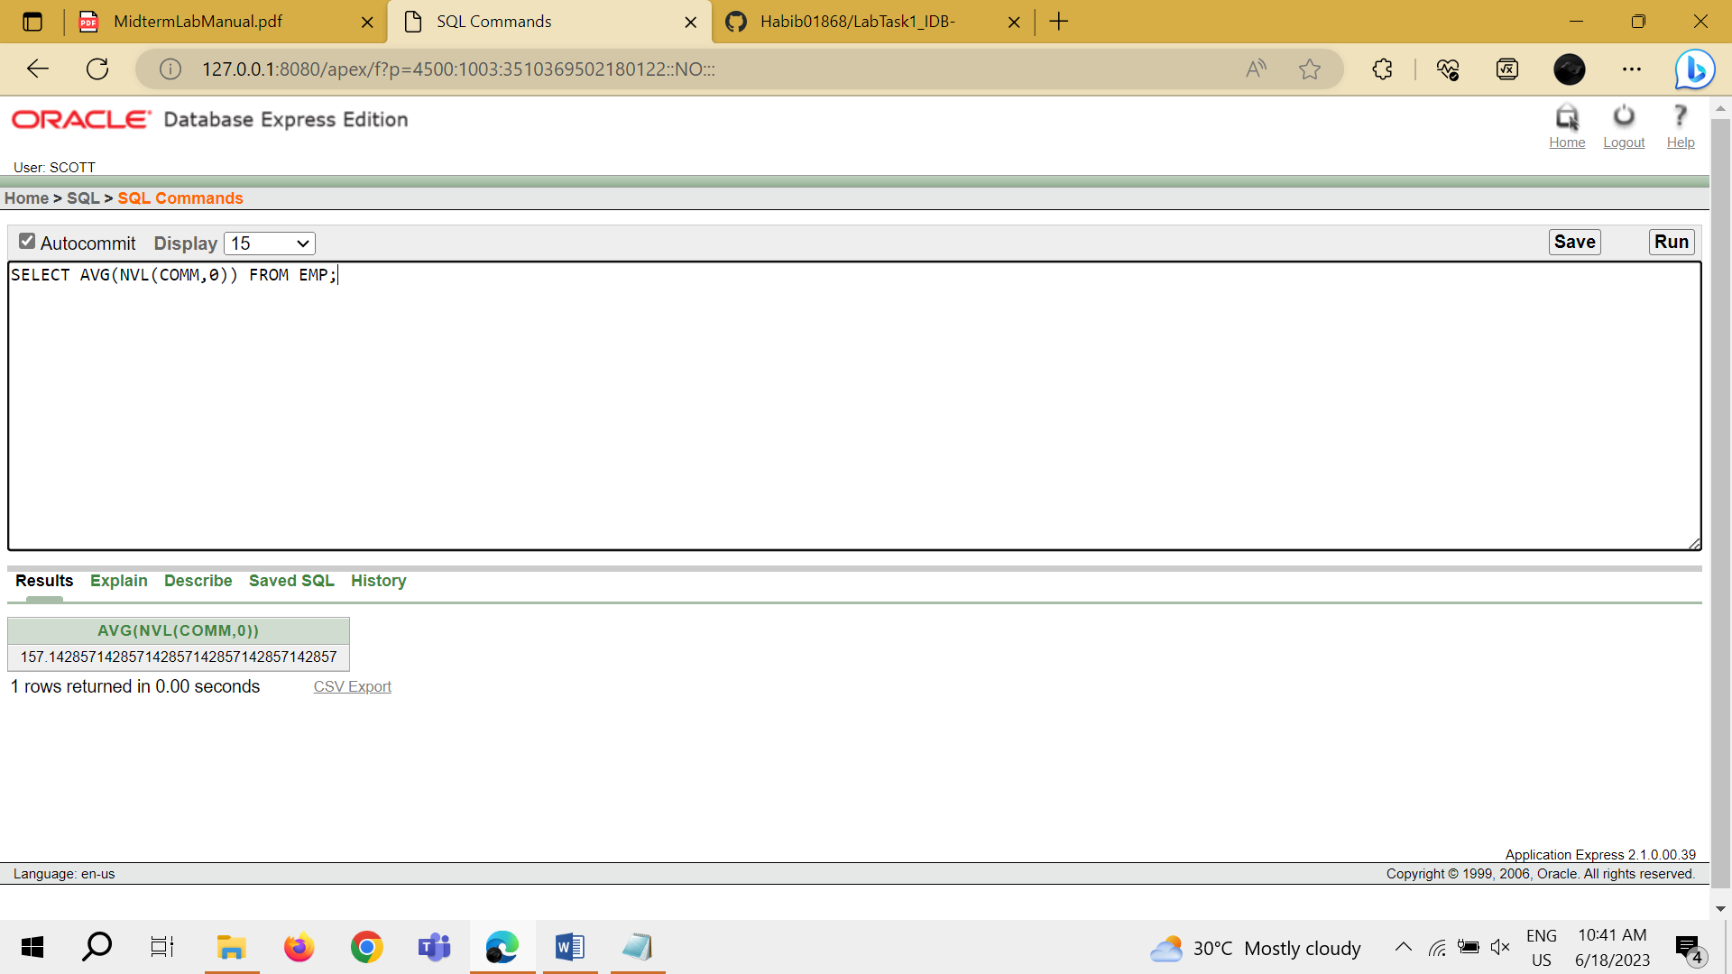

TASK 7: SELECT DEPTNO, AVG (SAL) FROM EMP GROUP BY DEPTNO;

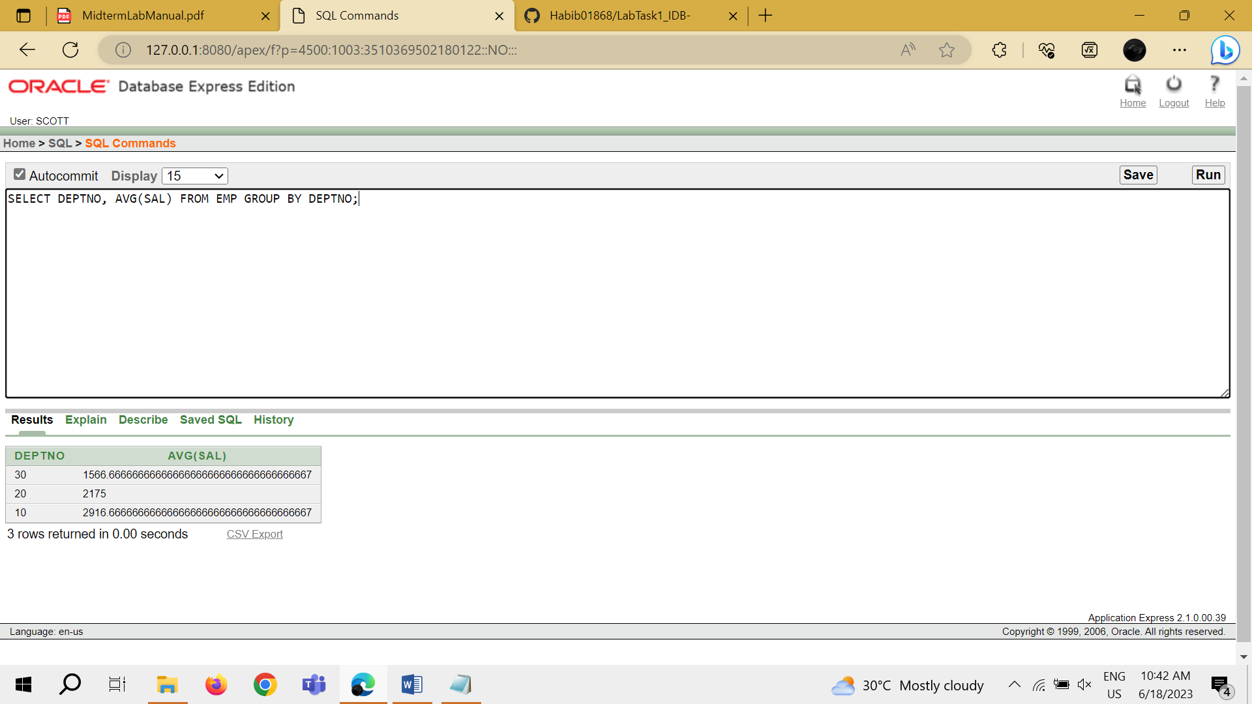

TASK 8: SELECT AVG (SAL) FROM EMP GROUP BY DEPTNO;

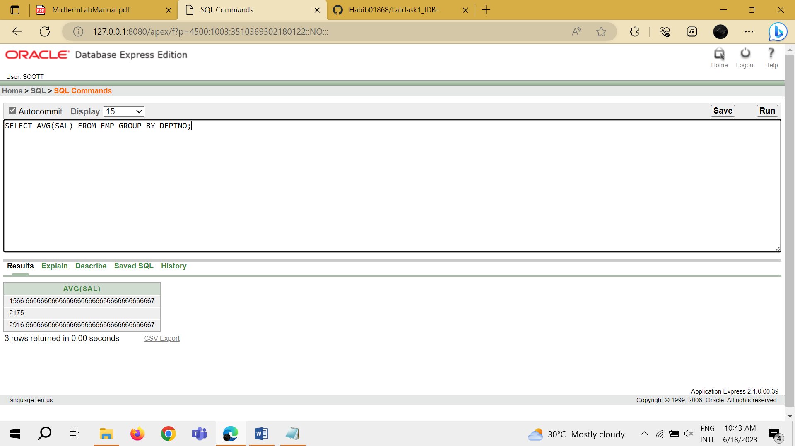

TASK 9: SELECT DEPTNO, JOB, SUM (SAL) FROM EMP GROUP BY DEPTNO, JOB;

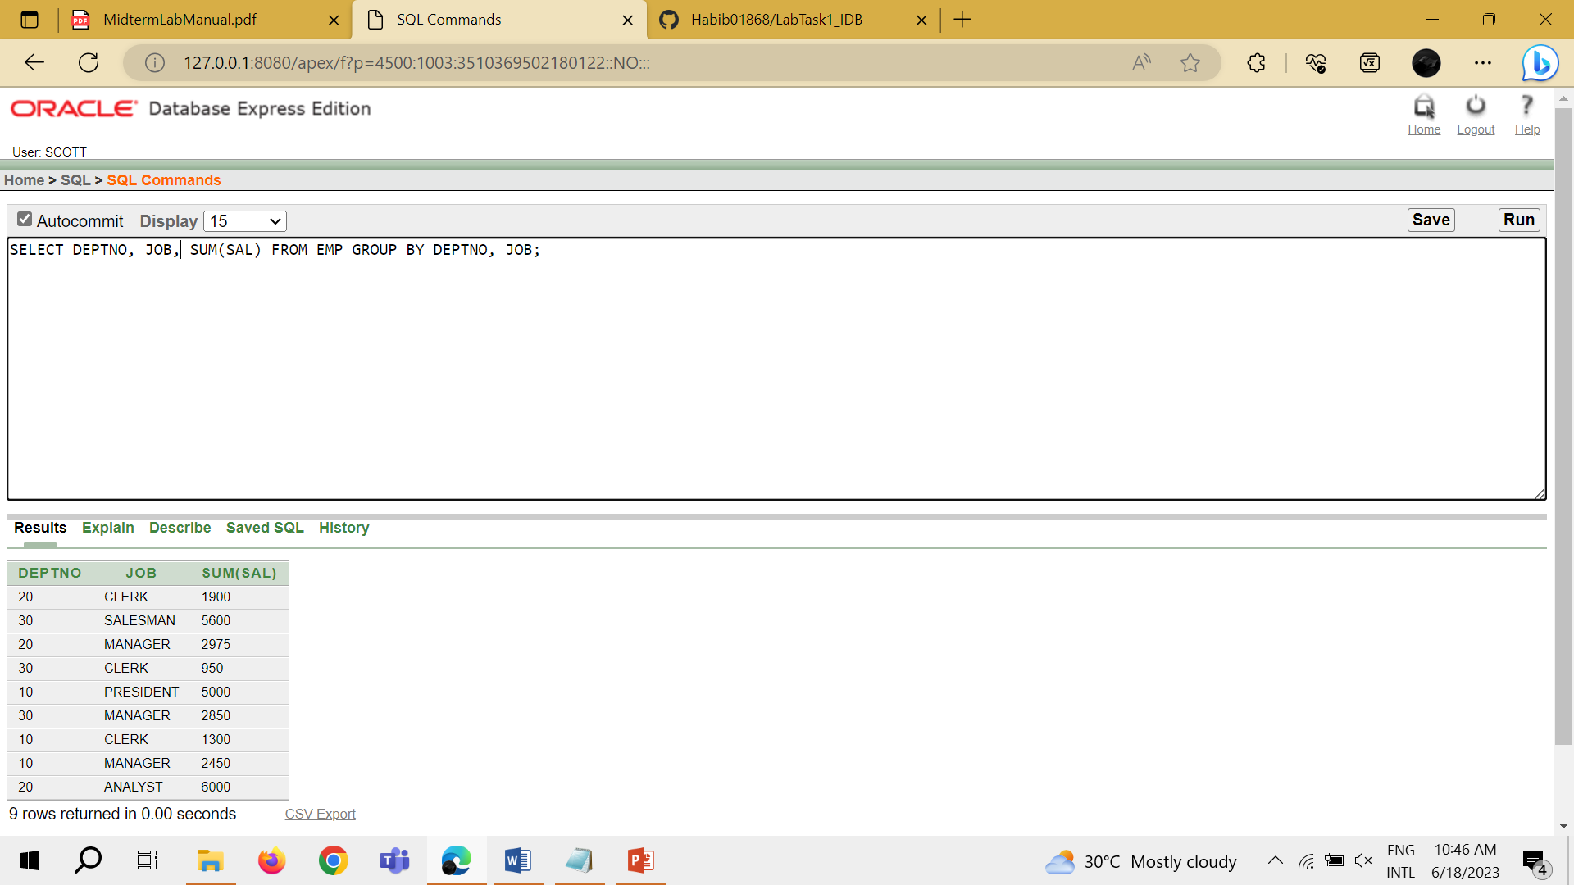

TASK 10: SELECT DEPTNO, COUNT (ENAME) FROM EMP;

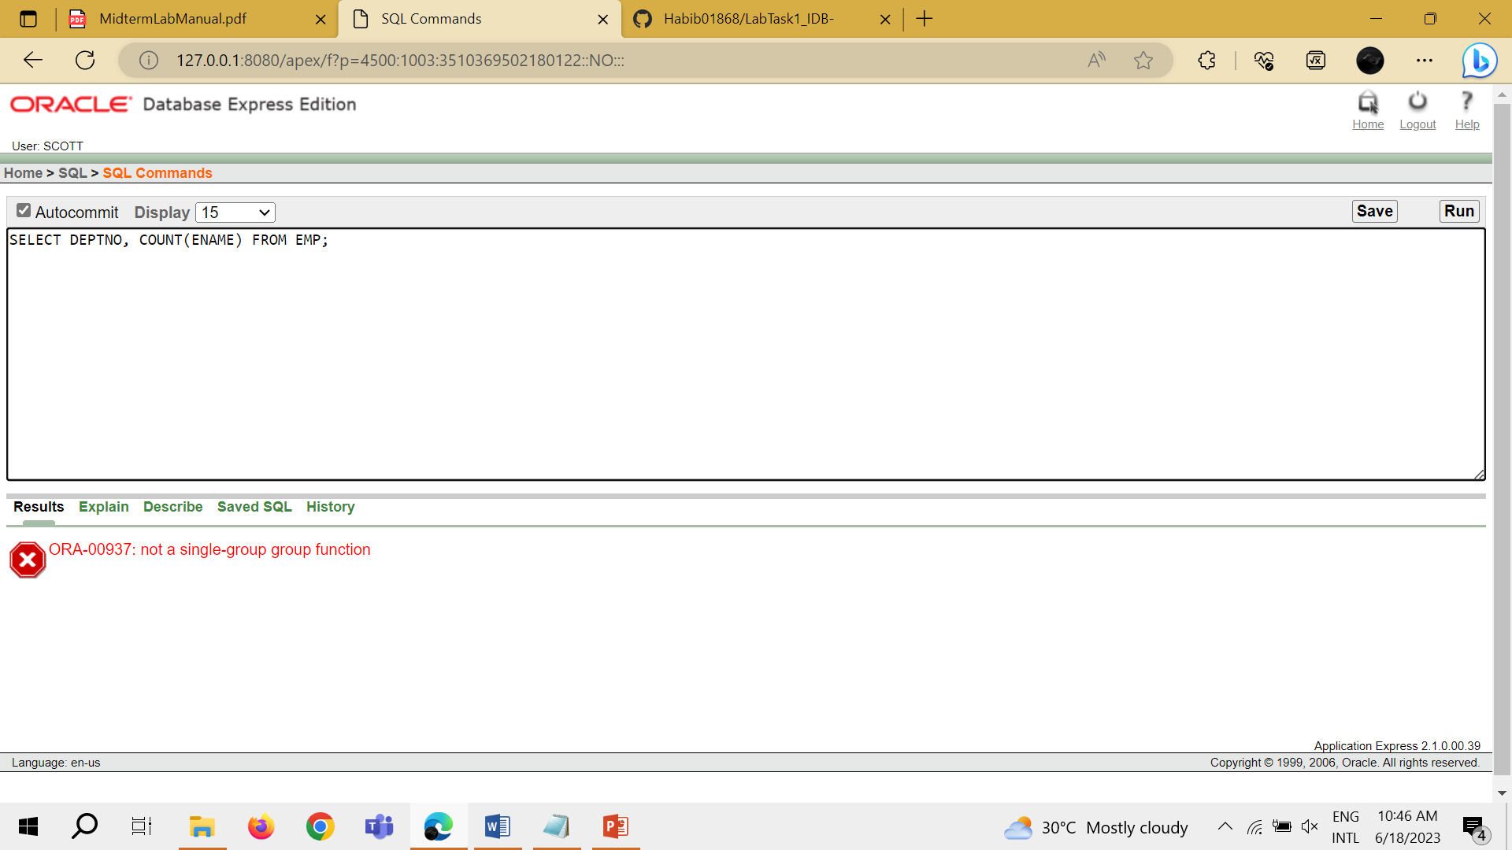

TASK 11: SELECT DEPTNO, AVG (SAL) FROM EMP WHERE AVG (SAL)>2000 GROUP BY DEPTNO;

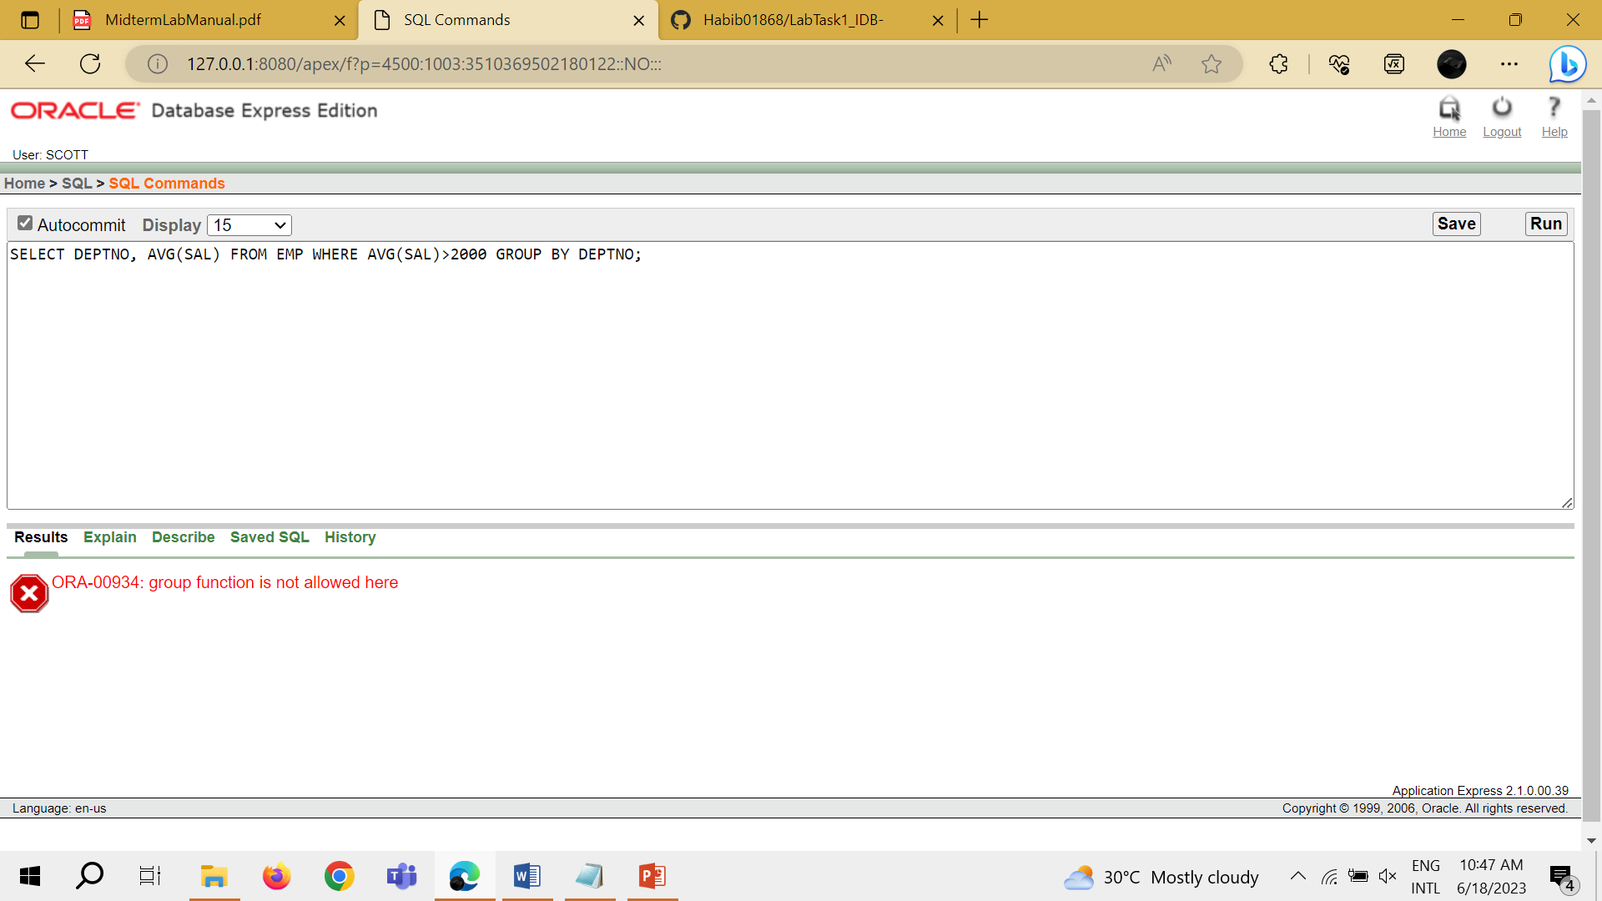

TASK 12: SELECT DEPTNO, MAX (SAL) FROM EMP GROUP BY DEPTNO HAVING MAX (SAL)>2900;

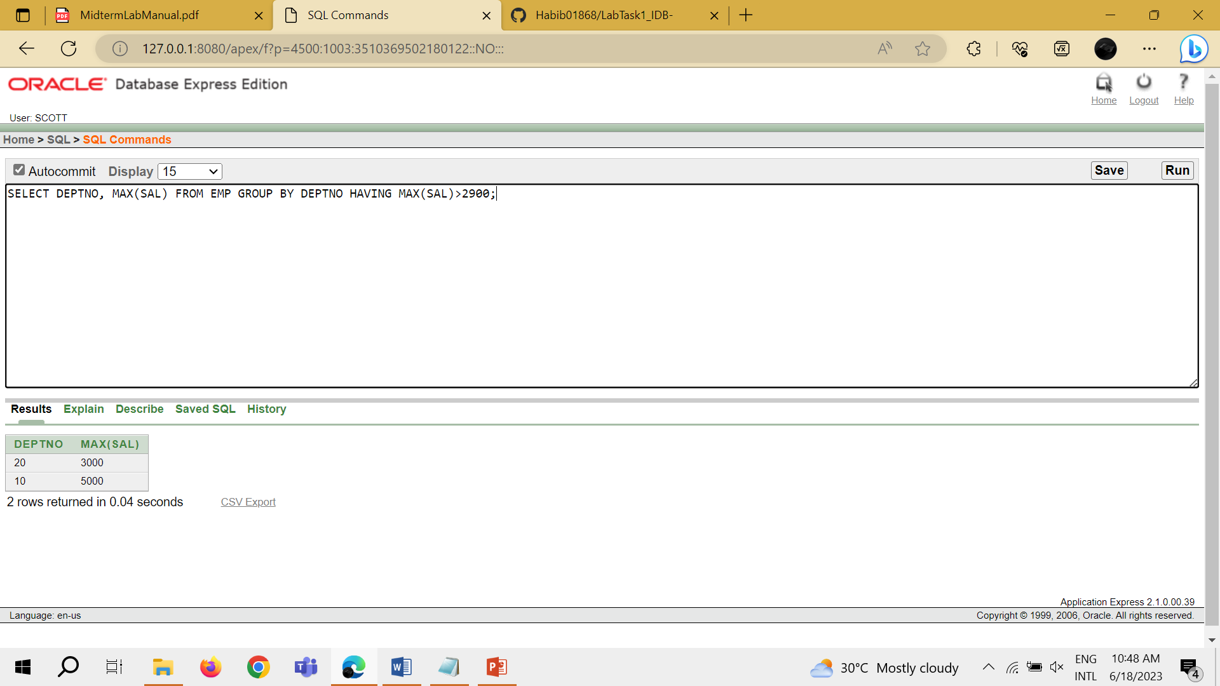

TASK 13: SELECT JOB, SUM (SAL) PAYROLL FROM EMP WHERE JOB NOT LIKE 'SALES%' GROUP BY JOB HAVING SUM (SAL)>5000 ORDER BY SUM (SAL);

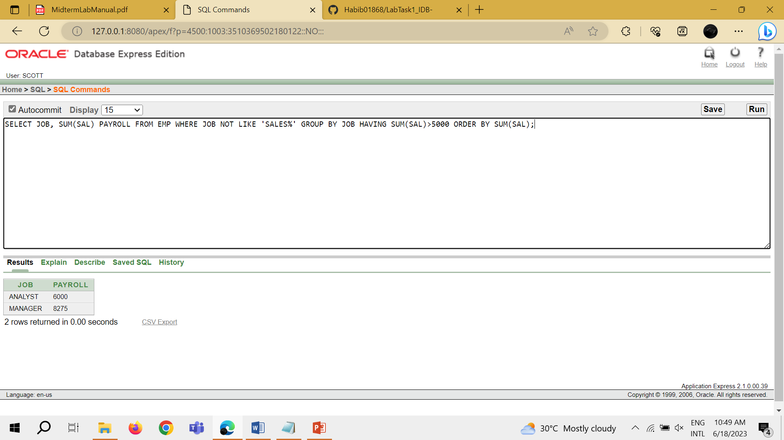

TASK 14: SELECT MAX (AVG (SAL)) FROM EMP GROUP BY DEPTNO;

